|  |
| --- |
| MTU Kerry |
| Capturing, Editing and Merging Gaussian Splats to Create Novel 3D Environments |
| Academic Year:2023/2024  Programme Title: Computing with Games Development – MT803  Module Title: Final Year Project  Module Code: PROJ 81003  Lecturer’s Name: Claire Horgan |

|  |
| --- |
| STUDENT Billy Elsbury T00224562 |

# Abstract

Gaussian Splatting, a rendering technique originating in the 1990s, has recently seen significant advancements, making it a possible alternative to traditional 3D rendering methods. This paper explores the potential and limitations of Gaussian Splatting for creating novel environments in various applications, including game development. The exploration of techniques for editing and merging Splats to generate unique and visually impressive 3D scenes. This paper examines the process of editing and merging Gaussian Splats and compares it with other emerging methods, such as Neural Radiance Fields (NeRF) and traditional photogrammetry. This research demonstrates how Gaussian Splatting can contribute to creating highly detailed and dynamic virtual environments.

# Introduction

Computer graphics, photogrammetry, 3D rendering, and game development are the main research areas relevant to this research project. A focus on applying Gaussian Splatting, a point-cloud-based 3D rendering technique, to create novel and visually compelling 3D environments.

Techniques for editing and merging Gaussian Splats are investigated, exploring their potential to alter Gaussian Splats to create unique 3D scenes for various applications, including game development. The research aims to assess its strengths, limitations, and potential contributions to 3D content creation.

Contents

Abstract 1

Introduction 1

Chapter 1. Literature Review 4

Introduction to Gaussian Splatting 4

From Video to Gaussian Splat 5

Gaussian Splatting in 3D Content Creation 7

Applications in Game Development 7

Photogrammetry 8

Gaussian Splatting & Photogrammetry 9

Emerging Techniques: NeRF and Beyond 10

Future Directions and Potential Improvements 11

Research Gaps and Opportunities 11

Integration with Other Technologies 12

Chapter 2. Methodology 13

Research Question 13

Data Capture & Gaussian Splat Creation 13

Performance & File Size Optimisation 16

Gaussian Splats in Game Engines 17

Collision Handling 17

Plugin Enhancement & Code Exploration 17

Chapter 3. Design 18

Chapter 4. Prototype Implementation 19

Prototype Development 19

Data Capture and Gaussian Splat Creation 19

Importing and Editing in Unity 20

Testing and Iteration 21

Merging and Adjusting Splats 25

Chapter 4. Implementation 28

Unity Project Development 28

Sprint 2: Unity Editing Tools: 27th January – 10th February 28

Identifying the Current Unity Splat Editing Tools 28

Editing the Project Code 31

Assessing the code: 31

Sprint Retrospective 36

Sprint 3: Unity Editing Tools Continued 37

Unreal Engine Project Development 38

Sprint 3: Capturing footage for Splats: 11th February – 24th February 38

Capturing Real World Footage 39

Capturing Video Game Footage 40

Importing Gaussian Splats into Unreal Engine 40

Sprint 4: Importing Splats into Unreal: 25th February – 24th February 41

Conclusion 42

Figures 43

References 45

# Chapter 1. Literature Review

## **Introduction to Gaussian Splatting**

The core idea of Gaussian Splatting goes back as far as described by Lee Westover in his 1991 dissertation “Splatting”. Westover derived the term Splatting "from a non-technical description of the feed-forward volume-rendering process" (Westover, 1991). Westover used the mental image of a snowball hitting a wall to inspire the name for the process, as it makes a ‘Splat’ sound, leaving “its contribution across the wall” (Westover, 1991). This analogy highlights the essence of the Gaussian Splatting process, where each volumetric data point (Splat) contributes to the final image by spreading its effect over the image plane and obscuring previous points for that view.

Westover suggested Splatting as a response to limitations in traditional triangle rendering, which often produced artefacts with limited interactive viewing. Westover found traditional rendering methods that “coerced the volumetric data into line and surface primitives” ​(Westover, 1991) could produce artefacts during data processing that could be mistaken for features in the data.

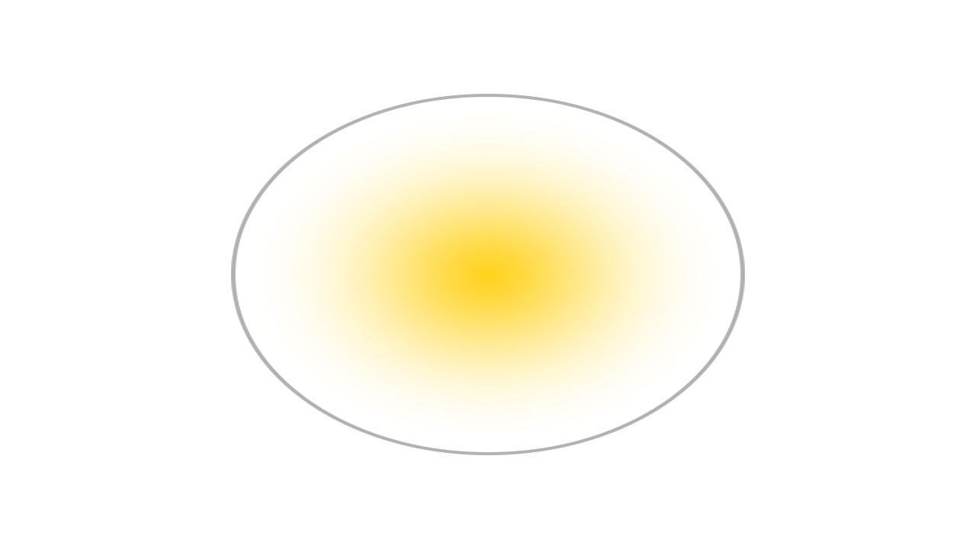

Figure 1 Rasterised Triangle & Gaussian representation (Ebert, 2023)

The core principles of Splatting revolve around its ability to map volume data onto an image plane without first transforming the data into geometric primitives. Gaussian functions are optimal for representing volume data due to their bell-curve-like (figure 2), which facilitates natural interpolation between data points.

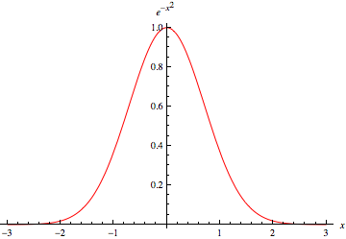

Figure 2 Gaussian Function (Weisstein, 2024)

One of the primary advantages of Gaussian Splatting is its computational efficiency. Using lightweight Gaussians Splats for scene representation enables efficient scene rendering, allowing real-time rendering of point cloud data with high visual quality (Kerbl et al., 2023). This novel approach to scene rendering allows for high visual fidelity while maintaining fast training times (Kerbl et al., 2023).

Despite the potential advantages of Gaussian-based rendering, Gaussian Splatting has limitations. The nature of using Splats for smooth blending of point cloud data can introduce artefacts during fast movement or view rotation and may struggle with representing high-frequency details (Radl et al., 2024). Additionally, while real-time rendering at high resolution is achievable, complex scenes may still face challenges in maintaining performance and visual clarity at the highest quality levels.

### From Video to Gaussian Splat

The process of Gaussian Splatting in its current form primarily came from a 2023 paper, “3D Gaussian Splatting for Real-Time Radiance Field Rendering” (Kerbl et al., 2023). It was found that Neural Radiance Field (NeRF) rendering methods at the time were lacking in performance and produced noise in the final image. It was proposed that 3D Gaussians (Figure 2) be used to represent the point cloud data, retaining high visual fidelity while improving training times and performance with the aim of real-time rendering.

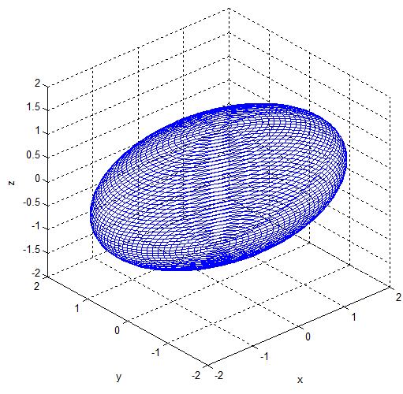

Figure 2: Visualisation of a 3D Gaussian model (Park et al., 2012).

The Gaussian Splatting process begins with the same inputs as other similar photogrammetry methods: the camera position between captured images is tracked with a technique such as “Structure-from-Motion” (SFM) (Snavely, Seitz and Szeliski, 2006). The sparse point cloud produced in the SFM process can be initialised with 3D Gaussians derived from the original captures. The properties of these 3D Gaussians can be optimised to fine-tune their position and opacity to best match the original capture; the visual fidelity is improved with sorting and blending optimisations. Additionally, the anisotropic trait of the Gaussian Splatting process allows the Splats to represent the captured view from that angle best and improve accuracy when viewed from a novel perspective (Kerbl et al., 2023).

## **Gaussian Splatting in 3D Content Creation**

**Gaussian Splatting offers a promising alternative to traditional 3D rendering, with applications in game development, virtual environments, and interactive 3D content creation. As a volumetric rendering approach, Gaussian Splatting diverges from polygonal and mesh-based models, which dominate the field, offering unique benefits and constraints when used to generate complex 3D scenes.**

### **Applications in Game Development**

**Gaussian Splatting presents new possibilities for creating immersive and efficient environments in game development yet faces limitations in its early implementation stages. The core advantage lies in its ability to render point clouds as coherent scenes with minimal processing time. Gaussian Splatting could streamline rendering workflows for high-fidelity games by bypassing resource-intensive mesh generation. However, practical adoption is hampered by its current constraints: lack of dynamic lighting models** (Fei et al., 2024)**, limitations in physics integration, limited tools for editing, and the absence of Level Of Detail (LOD) adaptations, which are critical for rendering performance in large interactive scenes** (Luebke et al., 2002)**.**

The concept of Level of Detail (LOD) was originally introduced by James H. Clark in 1976, highlighting the efficiency of dynamically adjusting graphical complexity based on the viewer's perspective to enhance rendering performance while conserving computational resources (Clark, 1976). LOD processes are often utilised in video games but do not directly apply to Gaussian Splats, as the memory and processing power required to store and render each splat does not inherently scale with distance like traditional meshed geometry does.

**The inability to re-light scenes dynamically comes from the Gaussian Splatting process using fixed, pre-computed lighting baked into the Splat colours** (Fei et al., 2024)**; these colours can be adjusted in an application such as SuperSplat**(playcanvas.com, 2024) **to mimic lighting changes, as seen in** Figure 3 **and** Figure 4**, but do not accurately respond to lighting conditions, reducing utility in environments requiring dynamic lighting.**

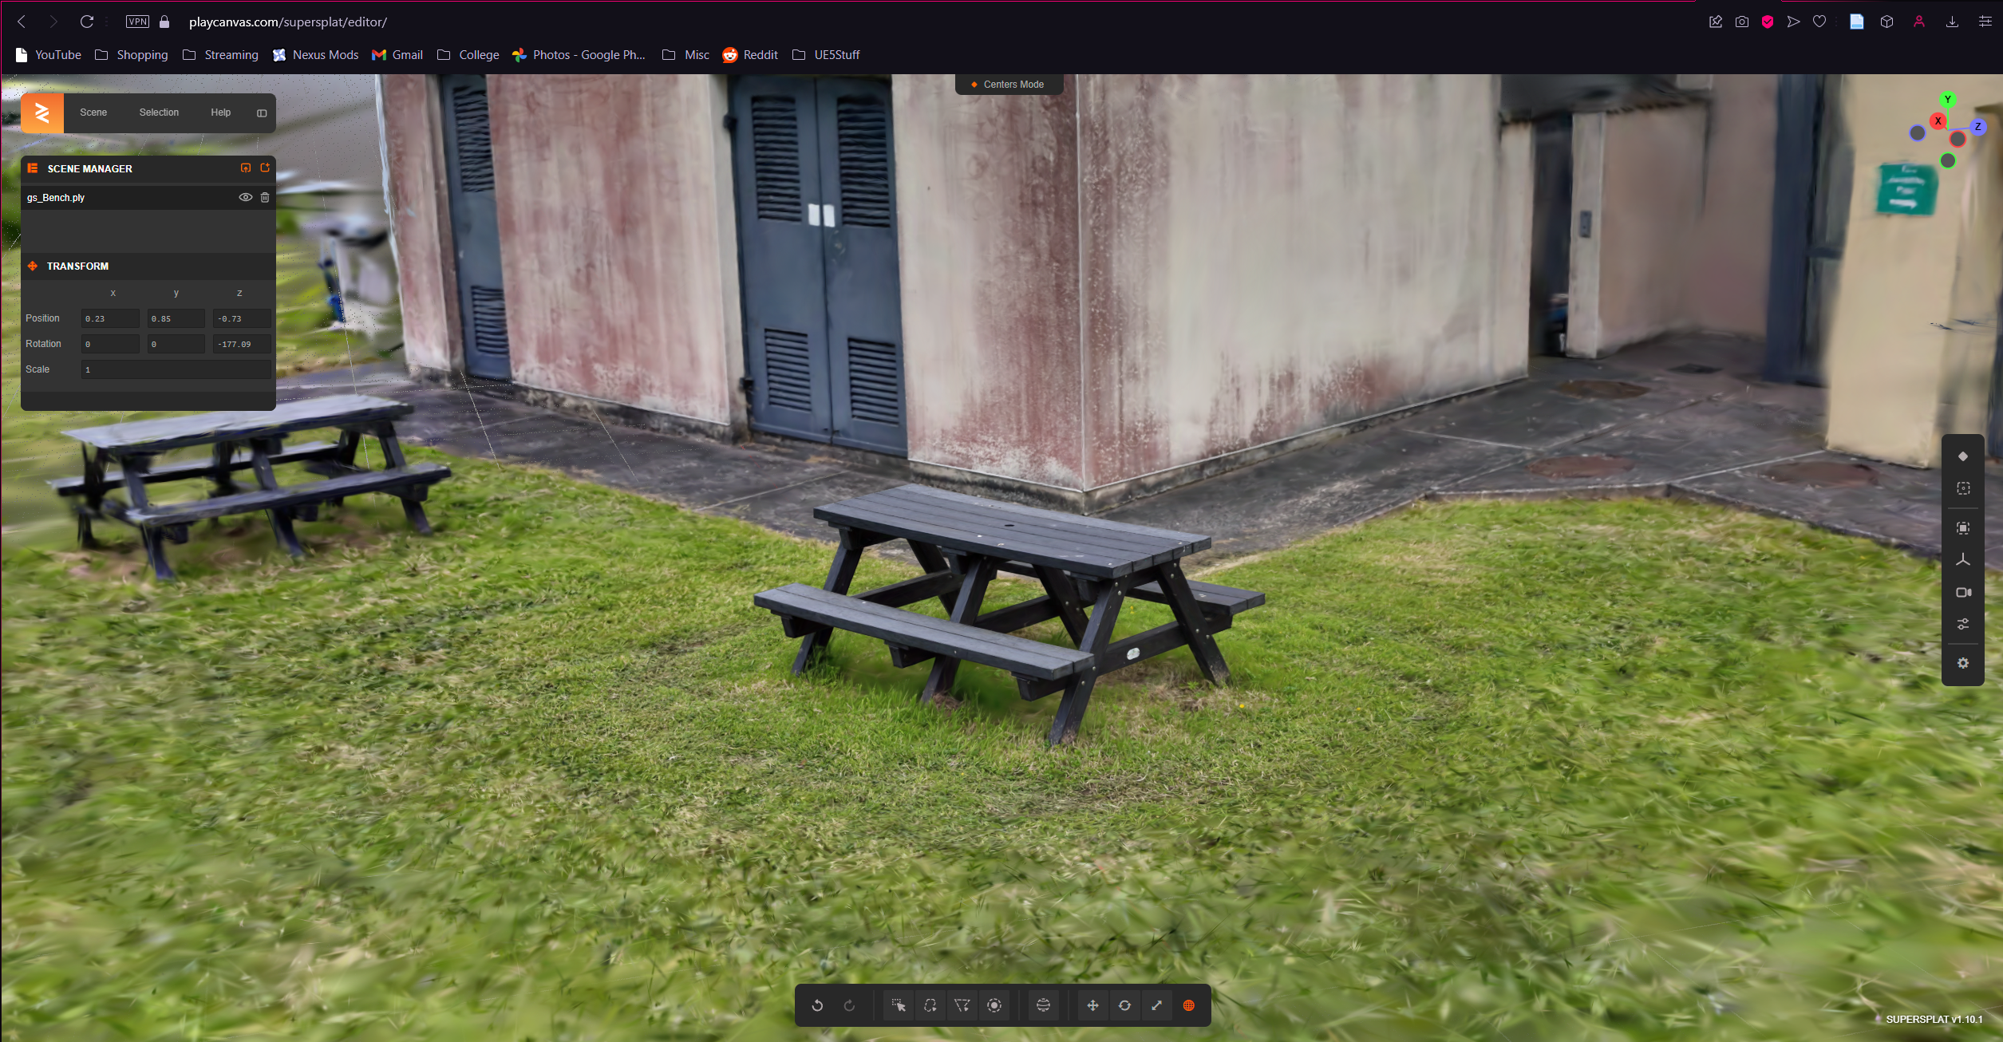

Figure 3: SuperSplat Original Colour

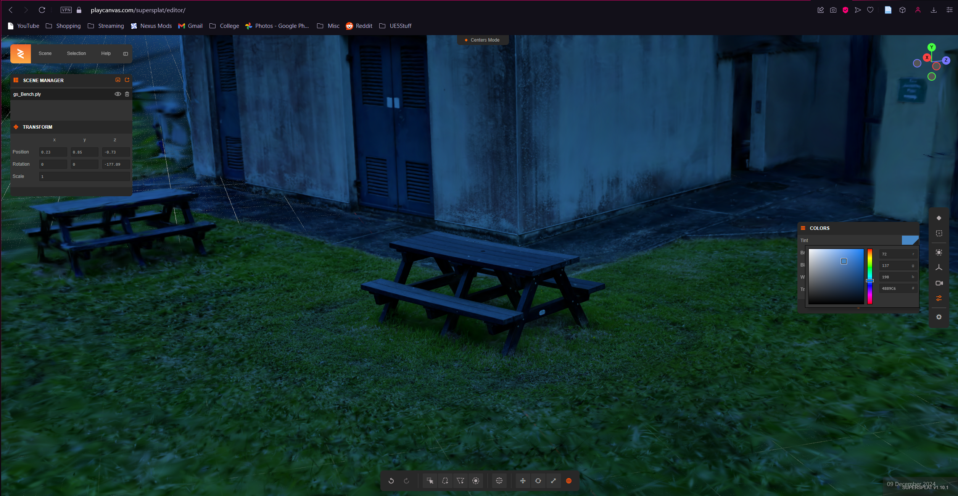

Figure 4: SuperSplat Edited Colour

### **Photogrammetry**

**Photogrammetry uses images to reconstruct detailed 3D models of real-world environments. The method of using photographs in measurement originated** as early as 1851 **from** Aimé Laussedat, **a French military engineer** (Albertz, 2007). Although Laussedat conducted experiments on hand-drawn images and later photographs for topographic mapping purposes, Laussedat called this method “Métrophotographie” (Albertz, 2007). Due to these initial experiments, Laussedat has been considered the “Father of Photogrammetry” (Albertz, 2007). There is, however, debate on how connected Laussedat’s experiments are to the development of photogrammetry as it is practised today (Polidori, 2020). The word photogrammetry itself, was applied later by German architect Albrecht Meydenbauer in an 1867 paper entitled “Die Photogrammetrie” (Beelitz, 1867).

One of the first uses of photogrammetry in video game development is the 2014 game “The Vanishing of Ethan Carter” by an independent Polish studio (Statham, 2020). The technique was quickly adopted by larger studios (Statham, Jacob and Fridenfalk, 2020) as a complex but valuable method to create photoreal scenes for video games.

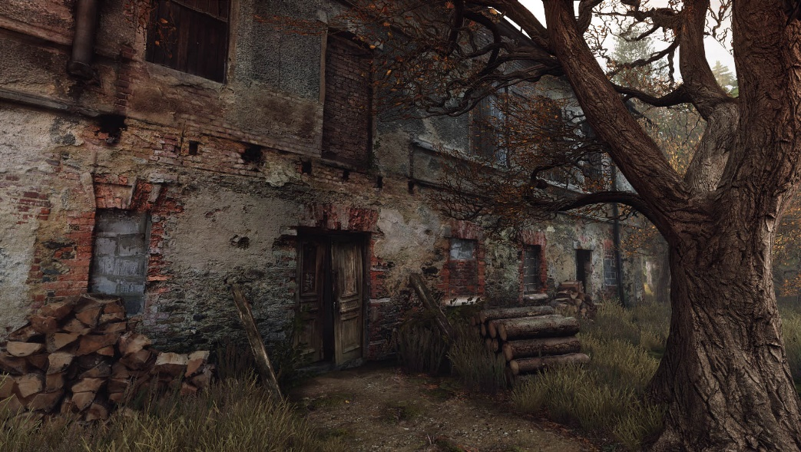

Figure 5: The Vanishing of Ethan Carter Photoscanned building (Poznanski, 2014)

### **Gaussian Splatting & Photogrammetry**

**Gaussian Splatting shares similarities with traditional photogrammetry in that both methods begin with camera-captured images and apply techniques like Structure-from-Motion (SfM)** (Snavely, Seitz and Szeliski, 2006) **to generate 3D data. Gaussian Splatting deviates in how it handles and renders this data. While traditional photogrammetry converts image data into meshes or voxel grids** (Snavely, Seitz and Szeliski, 2006)**, Gaussian Splatting employs low-weight Gaussian functions that allow smoother, more fluid transitions between data points** (Radl et al., 2024)**.**

**A notable difference lies in scalability and render speed: Gaussian Splatting’s lightweight nature allows faster rendering, making it better suited for real-time applications compared to photogrammetry’s polygon-heavy models, which can demand high processing power. This efficiency positions Gaussian Splatting as a potential solution for the increasing demand for video game quality and performance** (Atreya, 2022)**, as well as mobile and VR applications where performance constraints are a primary concern due to the limited hardware.**

### **Emerging Techniques: NeRF and Beyond**

**With advances in 3D content creation, methods like Neural Radiance Fields (NeRF)** (Mildenhall et al., 2020) **have gained traction for producing realistic and accurate 3D reconstructions. NeRF, which uses neural networks to predict the light intensity and colour across scenes, shares Gaussian Splatting’s goal of efficiently rendering point clouds but achieves this through deep learning. While NeRF can produce high-fidelity scenes, it requires significant computation and lengthy training times** (Mildenhall et al., 2020)**, which can limit its suitability for real-time applications.**

**Expand on NeRF a lot more what is it where/when did it come from etc**

**Gaussian Splatting offers a more immediate, lightweight solution with fewer computational demands than NeRF. However, Gaussian Splatting trades flexibility for fidelity due to the lack of meshed geometry. Both methods represent alternatives to conventional 3D models, but each has distinct needs and constraints. Gaussian Splatting's real-time performance aligns with applications prioritising speed and fluidity over intricate detail, whereas NeRF may be preferable when flexible meshed models are required.**

## **Future Directions and Potential Improvements**

Applying Gaussian Splats in 3D visualisation and game development offers significant potential, but it also reveals various opportunities for refinement. Despite Gaussian Splatting’s potential efficiency and novelty, current implementations and tools for working with Gaussian Splats have limitations worth acknowledging. Addressing these challenges can enhance their utility across a broader range of applications.

### Research Gaps and Opportunities

Gaussian Splatting shows significant promise for real-time rendering and 3D reconstruction (Wu et al., 2024), though some aspects can be further explored. An area for further investigation is the optimisation of splats for interactive applications, particularly in scenarios requiring dynamic lighting and shadowing. Existing methods prioritise statically lit environments (Dihlmann et al., 2024), which limits their adaptability to more interactive and immersive contexts, such as for use in video games.

The scalability of Gaussian Splatting when handling highly complex scenes with multiple layers of depth and occlusion has flaws. Gaussian Splatting lacks traditional level of detail (LOD) optimisations (Seo et al., 2024), which reduces potential performance savings when viewing Splats from different distances. Investigating strategies for dynamic Gaussian Splatting detail based on distance and advanced Splat lighting control could address these shortcomings and expand the possible applications of Gaussian Splats.

Potential Enhancements: Improving Editing Tools for Gaussian Splats

Current tools for editing and manipulating Splats often lack the necessary flexibility for fine-tuned control. Existing online platforms like Supersplat (playcanvas.com, 2024) and software like Unity do not support individual adjustments for key Splat properties such as colour, size, and transparency. These properties are limited as part of the overall Gaussian Splat, limiting the ability to tailor specific visual attributes during scene creation and editing.

Adding functionality to allow for individual control over the colour, size, and transparency of individual Gaussian Splats would significantly enhance their usability. Customisation of specific scene elements would make it possible to achieve more varied and nuanced visual effects from Splats. Similarly, the ability to adjust the size of Splats on an individual basis could assist in creating more complex and detailed scenes, potentially facilitating the scaling of Splat quality to vary based on their importance or proximity to the camera to mimic the utility of Level Of Details (LODs).

Transparency control would further expand the potential applications of Gaussian Splats. Transparency adjustments could optimise rendering by enabling certain parts of the scene to be more easily blended or masked, improving overall scene composition flexibility.

The flexibility and practicality of Gaussian Splats in game development and visual applications could be significantly expanded by incorporating individual Splat editing features into existing editing tools (Pranckevičius, 2024) or a custom plugin for platforms like Unity. This would open up new possibilities for creative workflows, allowing flexibility in a scene's details and overall rendering pipeline.

### Integration with Other Technologies

Gaussian Splatting could benefit significantly from integration with complementary technologies. Machine learning could automate aspects of Gaussian Splat generation and optimisation, such as predicting optimal settings for different use cases or generating adaptive Splats that dynamically adjust their resolution and properties based on distance or viewing angle. The successful integration of Gaussian Splatting for superior reinforcement learning vision tasks (Wang et al., 2024) opens up avenues for improving both fields. Reinforcement learning’s adaptive learning capabilities could enhance Gaussian Splatting by optimising Splat generation and adapting to dynamic lighting and quality based on viewing distance. Similarly, exploring the use of neural networks to enhance colour fidelity or predict occlusion could further elevate the visual quality of splats.

Beyond machine learning, combining Gaussian Splats with physics-based particle simulation systems may offer new possibilities for interactivity in virtual environments (Borycki et al., 2024). This could include dynamic collisions or deformation of splats to align with physical interactions, a feature usually limited due to Guassian Splat’s non-mesh nature.

# Chapter 2. Methodology

## Research Question

How can Gaussian Splats be edited and merged to create novel and visually impressive 3D environments for use in game development and beyond?

**Second semester, games-middleware assignment:** could a genetic algorithm be used with the NERF geometry of the scene to influence a set of colliders that would match the Gaussian Splat version of that scene? This would allow the visual fidelity of Gaussian Splats with the benefits of collisions for interactivity.

## Data Capture & Gaussian Splat Creation

The process of capturing and creating Gaussian splats involves several key stages, beginning with data capture and proceeding through various tools and techniques to refine and finalise the Gaussian Splat creation.

Once video footage or images are captured, the content can be processed using Luma AI (Lumalabs.ai, 2024) or Polycam (Poly.cam, 2024), both of which are web-based tools designed to convert 2D images or video into Gaussian Splats or NeRF representations, examples of which can be seen in Figure 6 and Figure 7 respectively. Luma AI and Polycam facilitate a streamlined, web-based process for converting video and images into Gaussian Splats.

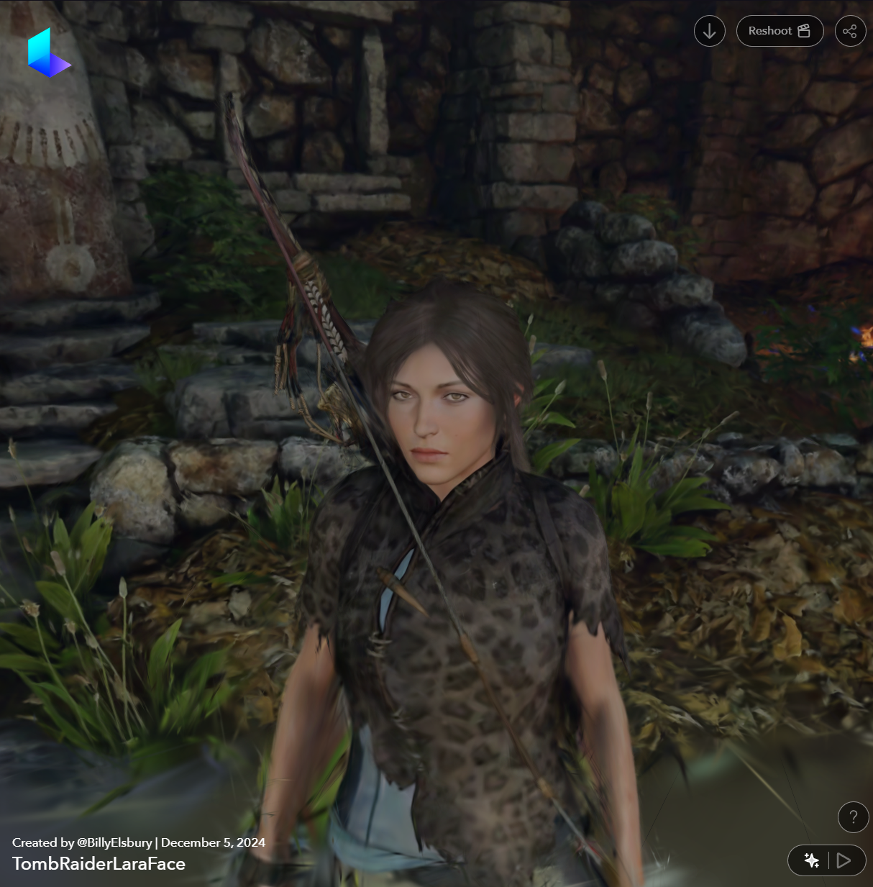

Figure 6: LumaAI Lara Croft Face Gaussian Splat

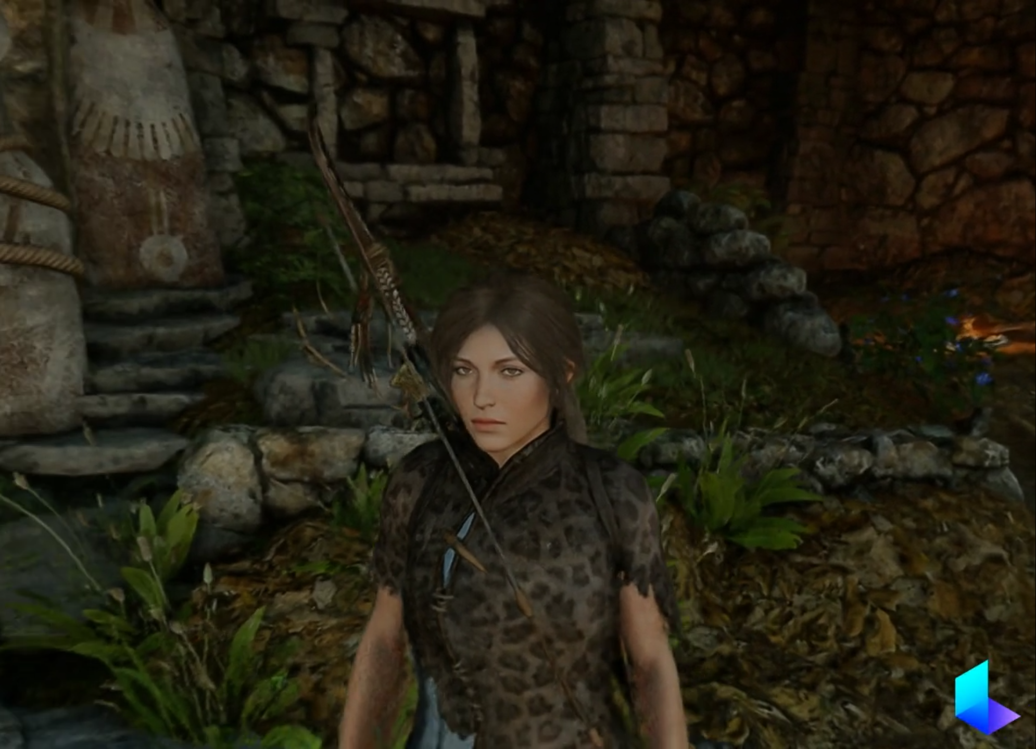

Figure 7: LumaAI Lara Croft NeRF

Jawset Postshot (Jawset.com, 2024) can be used as a local, hardware-based solution for more customisation and refinement of the Gaussian Splats. This tool allows for enhanced control over the creation of Gaussian Splats. Various parameters (Figure 8) can be specified before training, such as the number of images used, downsampling the resolution of the images, adjusting the number of features (3D points extracted), and determining the number of training steps. Postshot’s in-depth training settings improve the control over the quality of the outputted Gaussian Splat. Postshot allows for a more tailored result compared to the web-based automated solutions.

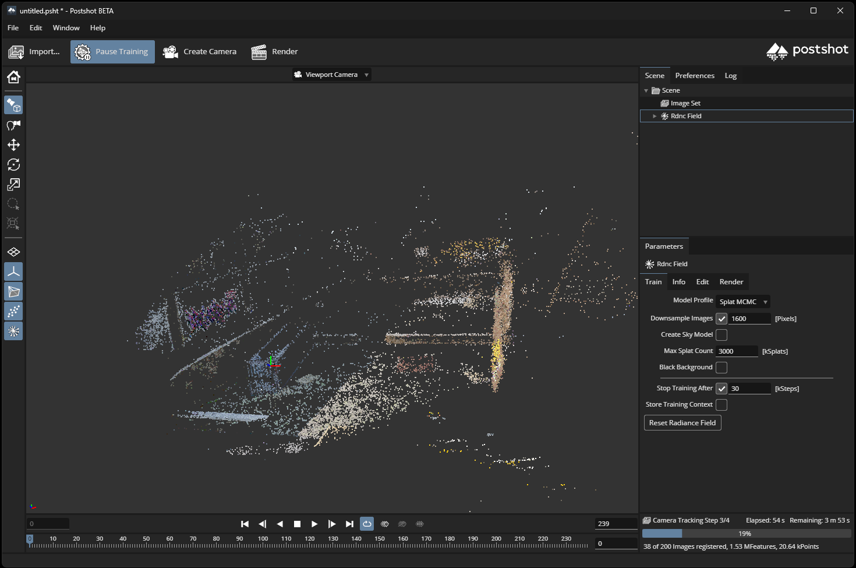

Figure 8: Post Shot Gaussian Splat Parameters

The original research paper on Gaussian Splatting (Pranckevičius, 2024) and its associated GitHub repository serves as a foundational resource for creating Gaussian Splats manually. The paper details the algorithms and best practices for creating Gaussian splats, ensuring that the generated splats meet the standards for the intended application. The repository provides sample code and implementation instructions to generate Gaussian Splats locally.

This combination of high-quality video capture, automated processing through web tools, and manual refinement via hardware-based solutions ensures that the generated Gaussian Splats are both high-fidelity and customisable, suitable for game development and further research.

## Performance & File Size Optimisation

Gaussian Splats offer advantages in terms of visual fidelity compared to traditional textured meshes used in video games. Due to their lightweight nature and efficient representation of 3D scenes, Gaussian Splats can achieve high visual realism with a low computational load and small file sizes. To optimise Gaussian Splat’s utility within game engines, file sizes should be reduced while maintaining an acceptable visual quality and performance level.

The file size of Gaussian Splats is primarily influenced by factors such as the number of Splats, their resolution, and the quality settings used during the creation process. Larger numbers of high-quality Gaussian Splats result in increased file sizes, which can reduce performance and utility, particularly in real-time applications like video games. Reducing the resolution/number of Gaussian Splats or simplifying their representation can help mitigate these performance issues, but this comes at the cost of scene complexity and visual fidelity.

Optimising Gaussian Splats for game engines requires balancing file size reduction and maintaining visual quality and scene complexity(the number of Gaussian Splats in a scene). Techniques such as downsampling, reducing the number of features (3D points) during the training process, or removing unnecessary Splats can achieve a better trade-off between performance and visual quality.

Using a lower-quality version of a Gaussian Splat can result in faster rendering times and reduced memory usage, but it may also cause fine details such as subtle surface textures or small-scale features, to be lost. Maintaining higher-quality splats ensures that fine details are preserved when editing, but this sacrifices performance, especially when large numbers of splats are used simultaneously.

Depending on the use case, such as blocking out a scene for later traditional asset creation, the relative loss in quality can be a valuable trade-off for the added performance of smaller file-size Gaussian Splats.

Ultimately, optimising Gaussian Splats involves balancing file size reduction with the quality required for their intended application. Regular testing and performance profiling are essential to ensure that optimisation strategies do not degrade a Gaussian Splat scene’s visual fidelity and utility while maximising performance.

## Gaussian Splats in Game Engines

Process of importing the Gaussian Splats into Unity and Unreal Engine:

Unity Integration: Use of the UnityGaussianSplatting plugin, methods for manipulating and editing Splats. That plugin provides good tools for editing, moving splats, boxes and ovals to mass hide and remove splats, and adjusting transparency and splat size globally, as well as combining multiple splats into one which gives accurate occlusion of splats. Some editing can only be done when using the high-quality versions of splats which have reduced performance and larger file sizes, but a method used was to edit using the high quality then re-export and import using the lower quality import.

Unreal Engine Integration: Challenges and limitations encountered in Unreal Engine with fewer editing tools but leveraging relighting capabilities.

## Collision Handling

Gaussian splats are not meshes and therefore do not have collisions. could a genetic algorithm be used with the NERF geometry of the scene to influence a set of colliders that would match the Gaussian Splat version of that scene? This would allow the visual fidelity of Gaussian Splats with the benefits of collisions for interactivity.

## Plugin Enhancement & Code Exploration

Potential to modify or extend the [UnityGaussianSplatting](https://github.com/aras-p/UnityGaussianSplatting) plugin C# code in Unity.

Ability to edit individual Splat properties (colour, transparency, size).

Sprint in implementation

# Chapter 3. Design

All in Separate Appendix for now

# Chapter 4. Prototype Implementation

## Prototype Development

The prototype development process for this project involved several iterative stages, starting with the capture and creation of Gaussian Splats, progressing through editing, merging, and refining these splats, and ultimately culminating in the construction of a demo prototype scene within Unity.

### Data Capture and Gaussian Splat Creation

Firstly, video footage of various locations was captured to generate Gaussian Splats. The footage was captured using a DJI Osmo Pocket 3 camera, which was on loan from the Agritech Centre of Excellence (ACE, 2024). The equipment provided ideal filming conditions, including high resolution and a gimbal lock-on feature, allowing smooth, stable orbits around the objects. Additional footage was captured from various video games, including Horizon Forbidden West, Far-Cry 5, Marvel's Spider-Man, Skyrim and Shadow of the Tomb Raider. The video game footage was captured using in-game photo-mode tools or external modifications where applicable.

A Python script was created to automatically move the camera in an orbit around an object, this movement provides the optimal Gaussian Splat generation footage (Hanke and Grussenmeyer, 2002).

Figure 9: Python Script Auto Camera Demonstration

The footage was then processed using Luma AI, a web-based tool for creating Gaussian Splats (Lumalabs.ai, 2024). Luma AI provided a convenient way to generate 3D point clouds that could be exported and used within game engines.

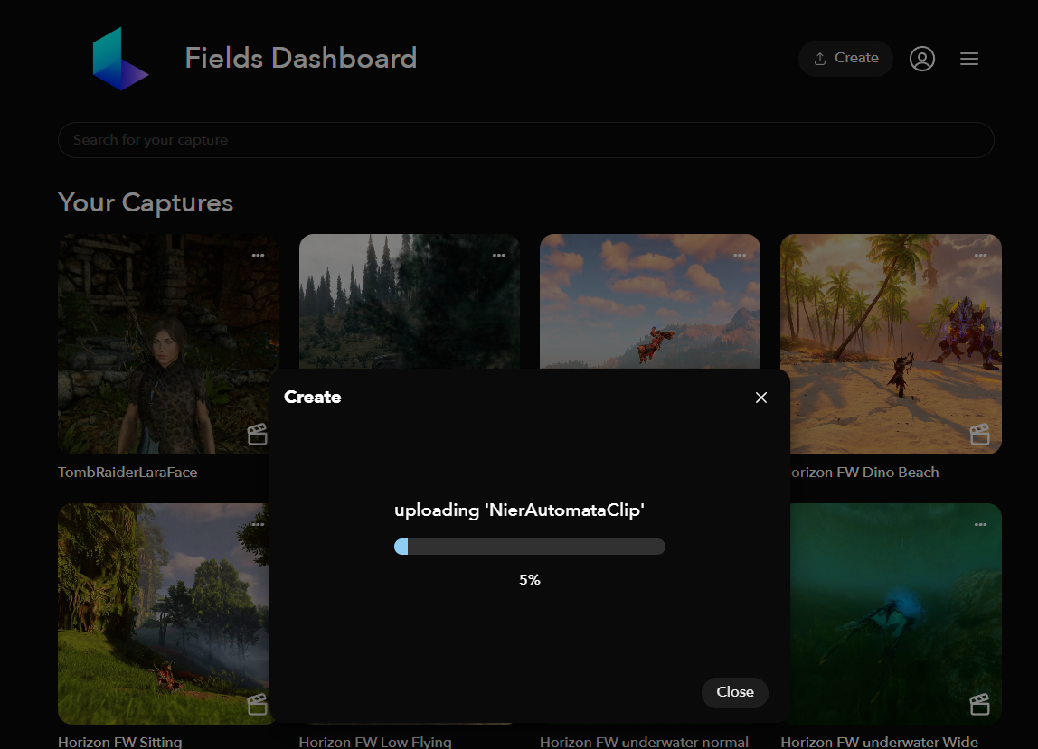

Figure 10: LumaAI Upload Example

Jawset Postshot, a local hardware-based solution, was utilised to produce more refined splats by leveraging its editable Gaussian splat-generating features, providing more customisable results. (Jawset.com, 2024).

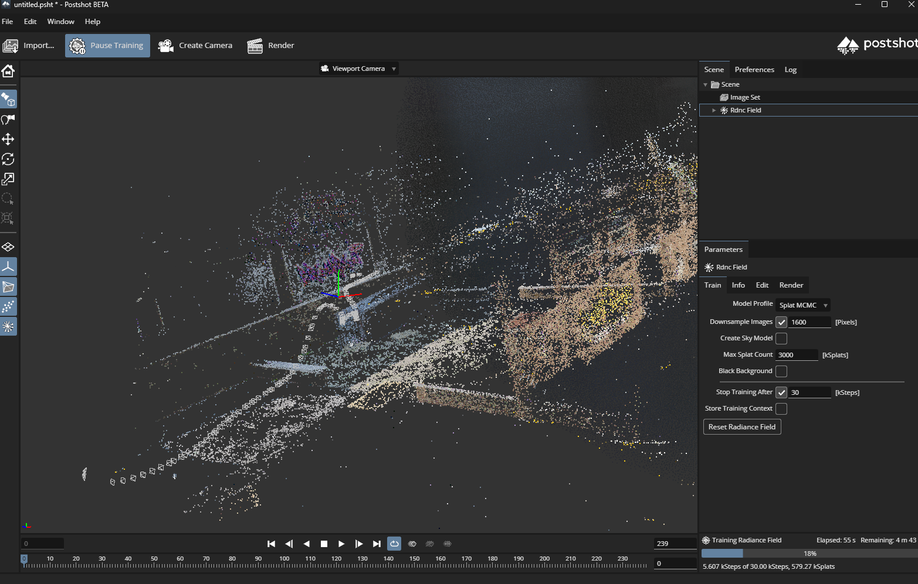

Figure 11: Jawset Postshot Training Example

### Importing and Editing in Unity

Once created, the Gaussian Splats were imported into Unity using the UnityGaussianSplatting plugin (Pranckevičius, 2024). This Unity plugin provided tools for importing Gaussian Splat ply files using different quality presets, which resulted in different file sizes. The plugin has tools for manipulating the imported Gaussian Splats, such as the ability to scale, move and delete individual or collections of Splats and edit the size and transparency of all the Gaussian Splats in the scene. The plugin provides the utility to combine multiple Gaussian Splats into one, ensuring accurate occlusion of Splats during rendering. If the Splats are not merged, the occlusion can display incorrectly as the Splats are “*very roughly* ordered, by their Transform positions” (Pranckevičius, 2024).

### Testing and Iteration

Throughout the prototype development process, regular testing was conducted to evaluate the performance and file sizes of the Gaussian Splats in the Unity scene. The primary metrics for testing included frame rate performance (FPS) and the Gaussian Splat PLY file size (Megabytes). Initial analysis showed that very large numbers of splats, primarily when used at high quality, led to noticeable performance drops. As a result, optimisations were made to reduce performance impact and file size without significantly affecting the visual quality.

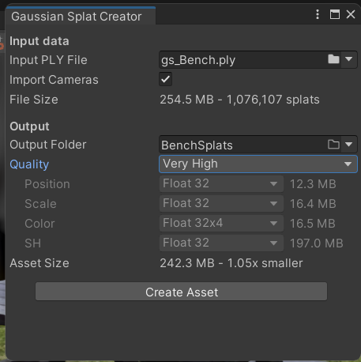

Figure 12: Very High Import Setting

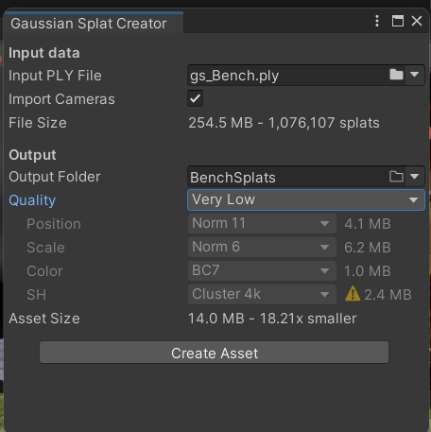

Figure 13: Very Low Import Setting

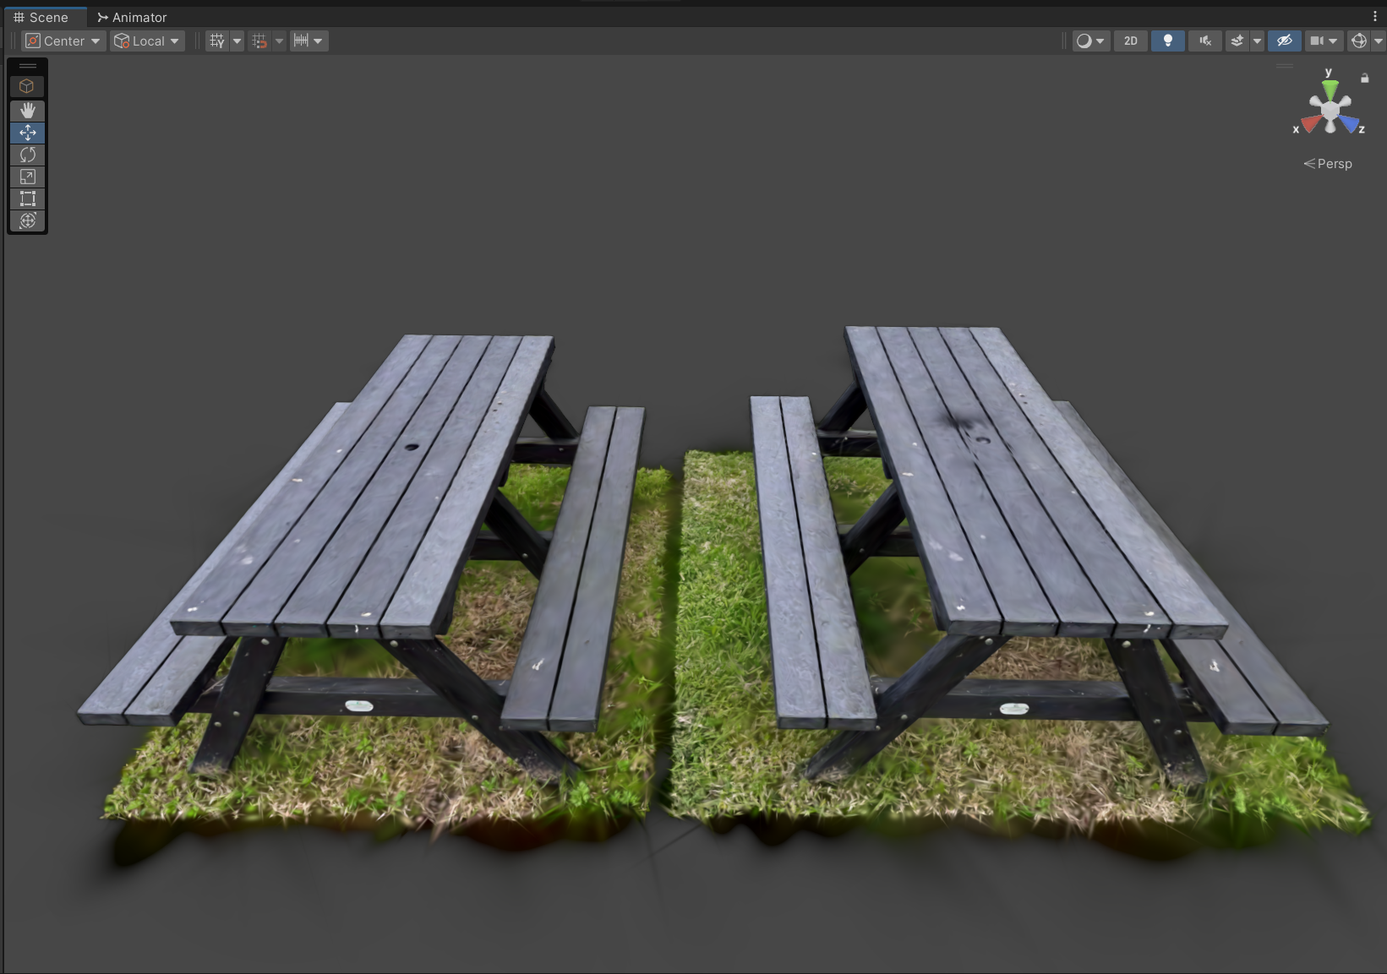

Figure 14: Gaussian Splat Comparison

Figure 14 displays the same Gaussian Splat imported into Unity using a high-quality preset (Left) and a low-quality preset (Right) for comparison purposes. Visually, the low-quality Gaussian Splat can be seen to be less accurate and lacks some finer details, especially on the surface of the table. However, the high quality Splat is also 17 times the file size at 242MB compared to the low quality at 14MB. The majority of this file size comes from the SH option, which stands for Spherical Harmonics. In the context of Gaussian Splatting, “the directional appearance component (color) of the radiance field is represented via spherical harmonics (SH)” (Kerbl et al., 2023).

With the high-quality import settings, each SH coefficient is stored as a highly precise 32-bit floating-point number, which retains accurate details in radiance and lighting. Accurate radiance representation helps define how the splat's colour and brightness vary based on the viewing angle and creates a more accurate Gaussian Splat.

With the low-quality import settings each SH coefficient is stored using a clustered quantisation approach, grouping similar SH coefficients into clusters. Using the cluster 4K option for SH import, the coefficients are heavily compressed, leading to a noticeable loss of detail in Splat accuracy. This loss of quality can be seen in the surface of the bench in Figure 14.

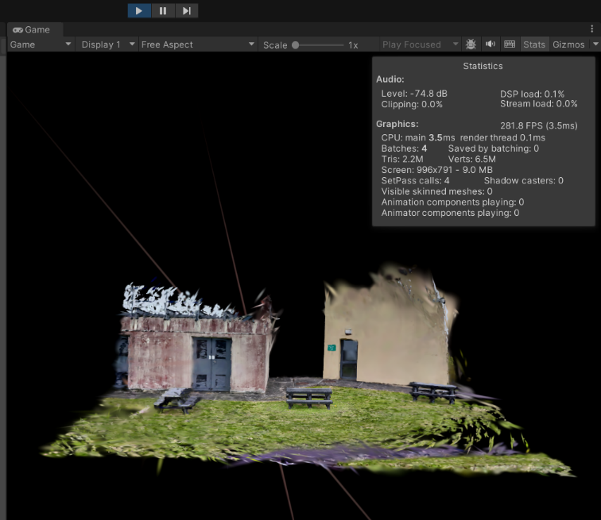

Figure 15: High-Quality Import Performance Metrics

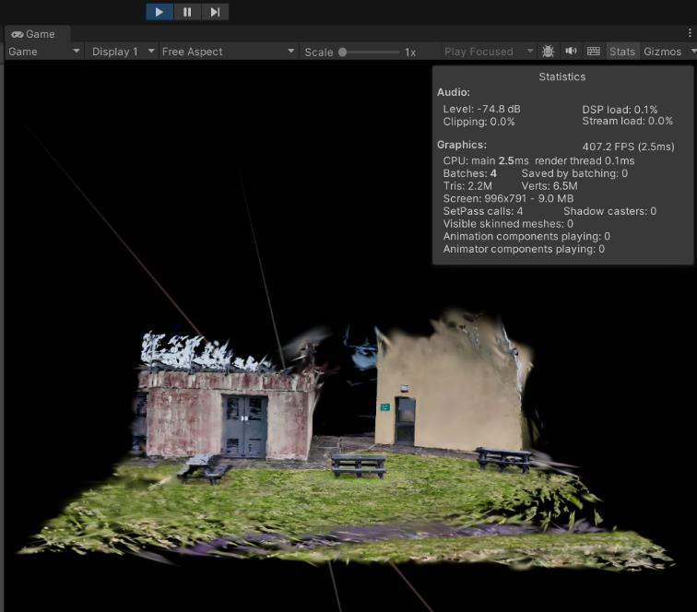

Figure 16: Low-Quality Import Performance Metrics

The performance impact of importing Gaussian Splats with high and low-quality settings is illustrated in Figure 15 and Figure 16 by the difference in the number of frames per second (FPS) that are being rendered in the Unity game view. These tests were conducted on Unity 2022.3.47f1 using a system with an AMD RX 6950 XT GPU, a Ryzen 7 5600X CPU, and 32 GB of RAM. When using high-quality import settings for the same Gaussian Splat, the FPS averaged 280, compared to an average of 400 FPS for the low-quality import. Although no specific performance optimisations were used for these tests beyond cropping and adjusting import quality, the performance metrics indicate the importance of considering the scene's performance when using Gaussian Splats. Careless importing and excessive use of multiple Gaussian Splats can lead to a significant decrease in performance.

The lower FPS associated with the high-quality import reflects the increased computational demand caused by the detailed radiance data stored in 32-bit floating-point SH coefficients. The precision of these coefficients allows for a more accurate representation of each individual Splat, contributing to the enhanced visual fidelity of the Gaussian Splat. However, this comes at the cost of higher file sizes and greater processing requirements.

In contrast, the low-quality import utilises clustered quantisation, which reduces the computational workload by compressing the SH coefficients. This simplification increases FPS but reduces some finer visual details, as seen in the surface textures and shading accuracy on the top of the bench in Figure 14 and can be seen as well in the outer grass in Figure 15 and Figure 16.

While the observed performance metrics are satisfactory on this hardware for scenes with a single Gaussian Splat, performance considerations will become increasingly critical as more Splats are imported, merged, and edited within the Unity scene. This consideration extends to lower-grade hardware performance; the combined file size and computational requirements of multiple high-quality Splats could lead to notable performance degradation. To maintain an FPS above 60, the optimal minimum for interactive real-time applications (Ionos.com, 2023), careful management of Splat quality, scene complexity, and optimisation techniques is necessary.

This analysis highlights the trade-off between visual fidelity and performance when using Gaussian Splats, reinforcing the importance of tailoring import settings to the application's requirements.

To mitigate performance issues, editing was done on Gaussian Splats using high-quality import settings then the Splats could be exported and re-imported using lower-quality settings. This workflow optimised performance and file sizes while allowing the use of all the editing tools without significantly compromising visual fidelity.

### Merging and Adjusting Splats

Merging Gaussian Splats involved combining multiple Splats into a single scene, enabling the creation of novel environments by blending Splats from various applications. This prototype implementation combined splats from two distinct real-world locations, the interior of [Carrigafoyle, Ballylongford, Co. Kerry](https://www.google.com/maps/place/data=!4m2!3m1!1s0x485adbf4257ad181:0x503ccd5e953e7ac1?sa=X&ved=1t:8290&ictx=111) and a bench outside the [Tom Crean Business Centre](https://creancentre.com), with assets derived from several video game environments, resulting in a novel hybrid scene that retains visual coherence while showcasing diverse aesthetic elements. The merging process was performed within Unity, where splats were aligned and scaled to ensure correct occlusion and seamless integration.

The Gaussian Splats do not always correctly occlude one another when imported into Unity this way. This is due to the way the Unity plugin orders the Splats. The Splats are “*very roughly* ordered, by their Transform positions”; however, depending on position and scale, they can appear to overlap incorrectly. An example of this incorrect occlusion can be seen in Figure 17 where the lower bench is rendered incorrectly in front of the higher one; the occlusion issue is rectified once the Gaussian Splat components are merged into one, and the Splats can be correctly ordered individually to occlude accurately.

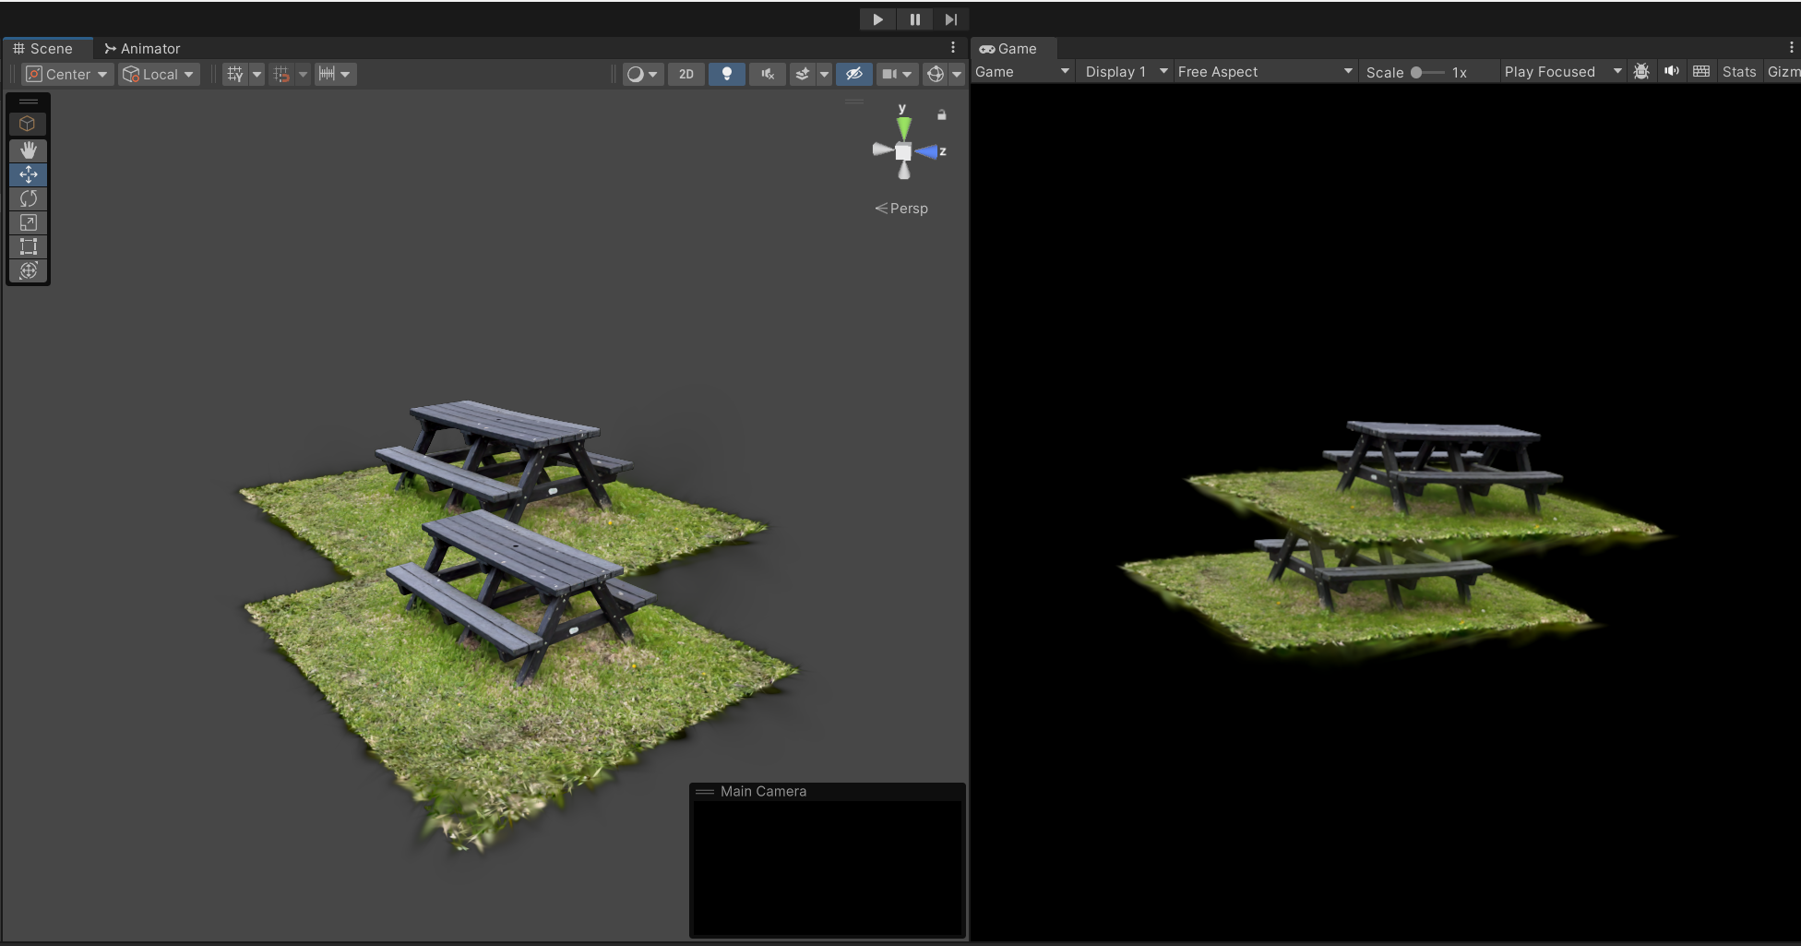

Figure 17: Incorrect Splat Occlusion Example

A final prototype demonstration scene was created, combining multiple edited Splats from different real-world locations and video games.

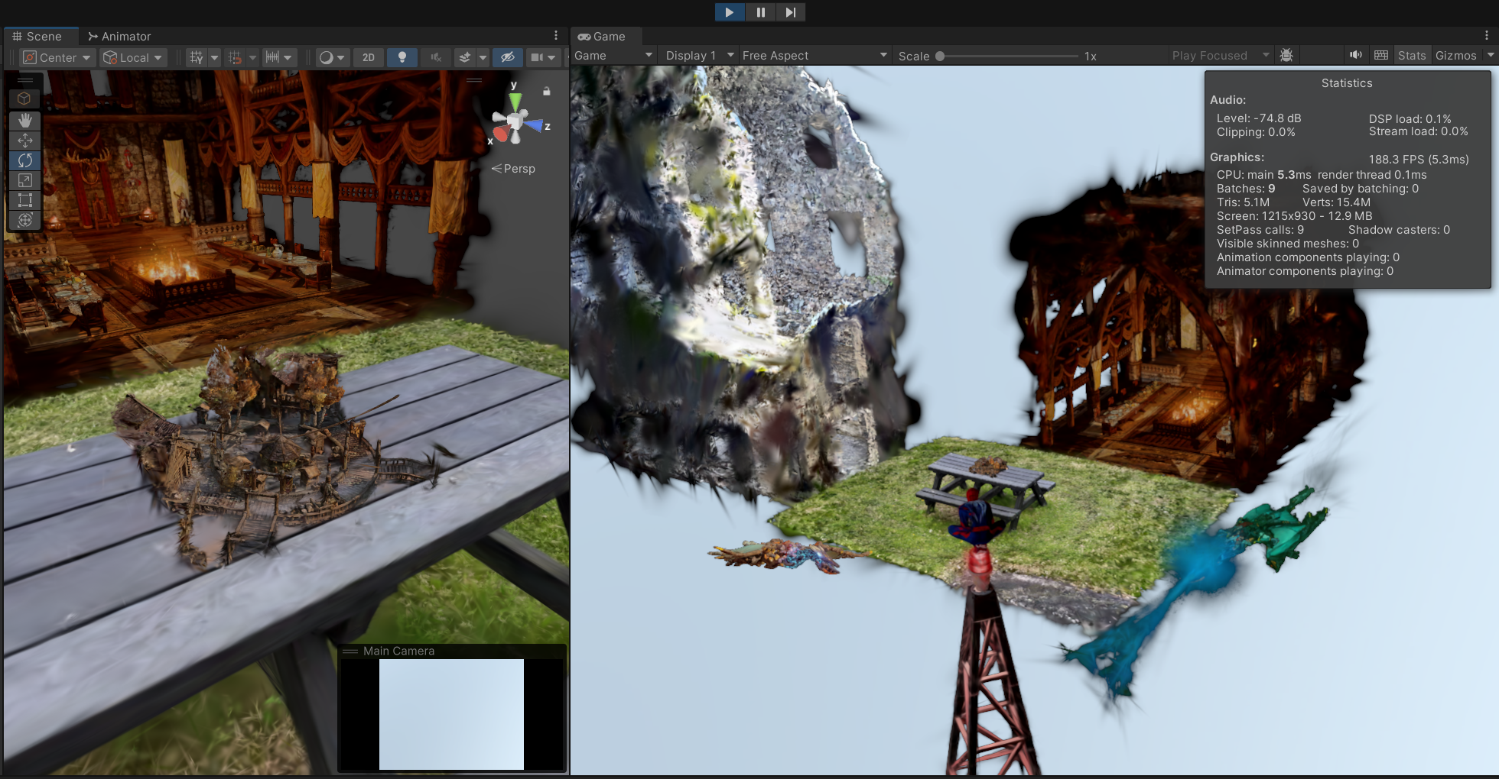

Figure 18: Final Merged Prototype Scene

A novelty available when editing and merging Gaussian Splats is the ability to resize and edit the Splats without losing quality, creating unique scenes by combining a variety of edited Splats. In figure Figure 18 a Gaussian Splat of a small village market from the video game Skyrim can be seen resized and placed on top of a Splat of a real bench, demonstrating the flexibility and novelty that can be created from Gaussian Splats.

The performance of 188 FPS shown in Figure 18, for a complex scene with seven combined Splats, a splat count of 2,568,648 and a file size of 32.9MB aligns with performance expectations. The performance metrics (Figure 19) support the workflow devised from initial testing and iteration, which includes editing at high quality, exporting, and reimporting at low quality. This approach maintains editability and visual fidelity while significantly improving performance. As further additions and complexity are introduced, monitoring scene performance remains crucial; however, initial Splat editing and merging demonstrates the relatively low-performance overhead of Gaussian Splats.

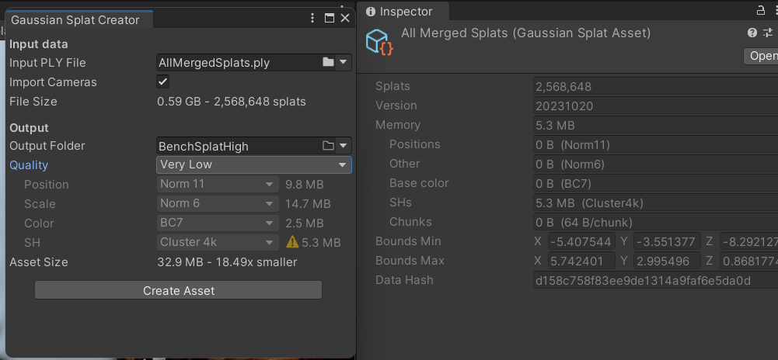

Figure 19: Final Prototype Stats

Despite this versatility, the editing tools currently available in Unity have limitations. Features such as tools to adjust individual splat attributes—size, transparency, and colour—are not present, restricting the creative potential of this workflow. Addressing these shortcomings could significantly enhance the flexibility and usability of Gaussian Splats in future implementations.

# Chapter 4. Implementation

## Unity Project Development

### Sprint 2: Unity Editing Tools: 27th January – 10th February

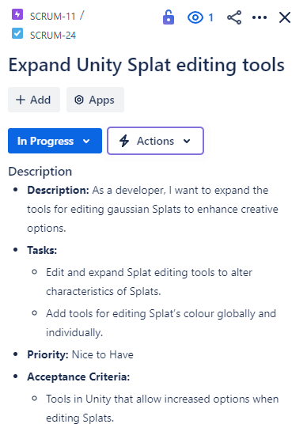

#### Identifying the Current Unity Splat Editing Tools

Importing Gaussian Splats into Unity followed the same procedure as that done when creating the prototype (Importing and Editing in Unity). The prototype scene was used to test alterations to the existing editing tools.

Currently, the [Github Repo](https://github.com/aras-p/UnityGaussianSplatting) project (Pranckevičius, 2024) is suitable for allowing the importing and exporting of Gaussian Splats in Unity (Figure 20), as well as allowing certain alterations to be made. However, there is a lack of tools for editing Splat attributes individually.

This sprint aims to edit the code of this Unity project to enable the editing of individual Splat parameters, such as colour, dimension, shape, and alpha, both globally and individually. This modification addresses the current lack of tools for adjusting individual splat attributes in this Unity project. These tool additions could expand the creative potential of this workflow, such as changing daytime scenes to night with global colour shifting and editing the colour of clothes or objects by individually selecting Splats.

It is worth noting that global colour changes can also be done by colour-correcting footage before the training and creating of the Splat. This process is less flexible, as once the Splat is trained, and imported into a scene, it will still be stuck with the the same colour attributes it was trained with.

(Could be worth researching the possibility of altering footage colour for improved Gaussian Splatting creation, such as boosting contrast to improve key point tracking for SFM (Snavely, Seitz and Szeliski, 2006))

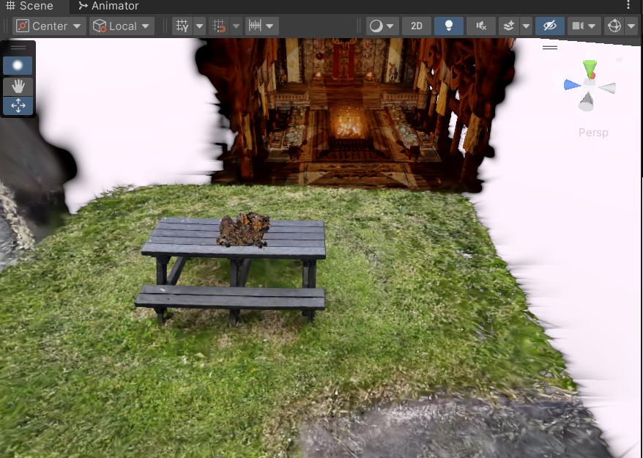

Figure 20: Unity Project Imported Gaussian Splat

The splats can be edited in a few ways, such as Individual Splats can be selected (Figure 21), they can then be moved (Figure 22) and can also be deleted (Figure 23).

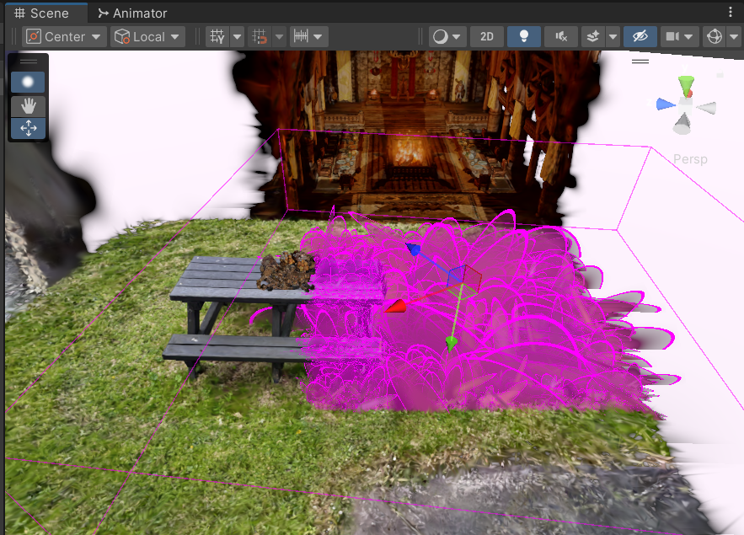

Figure 21: Unity Splat Selection

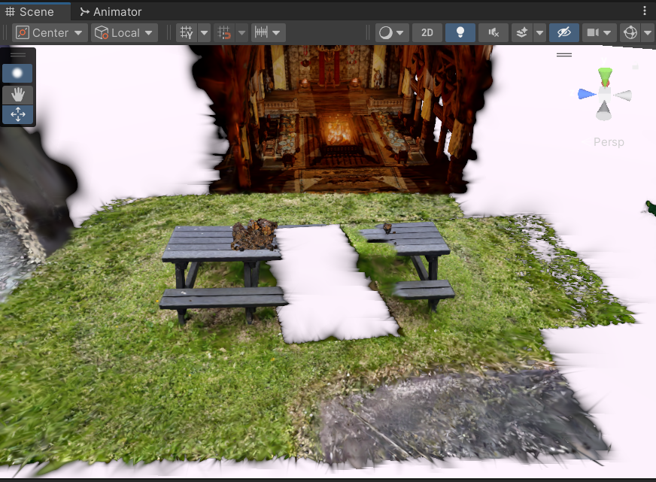

Figure 22: Unity Splat Movement

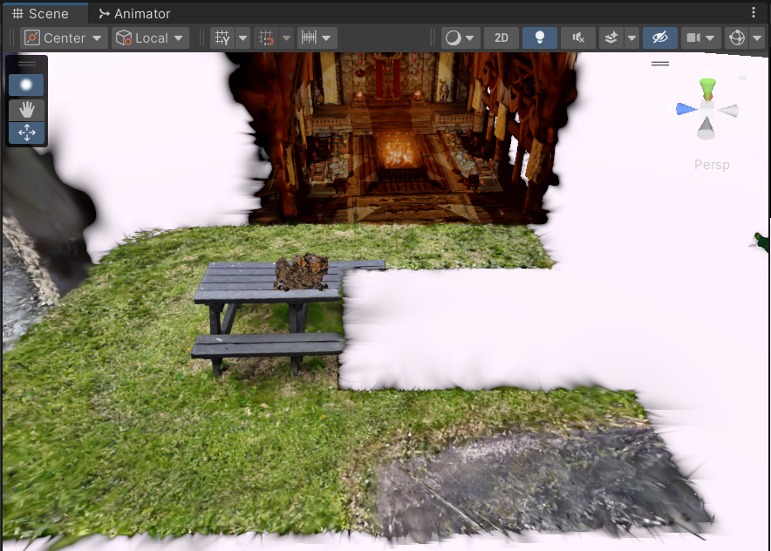

Figure 23: Unity Splat Deletion

Global attributes can also be altered such as scale (Figure 24) and opacity (Figure 25).

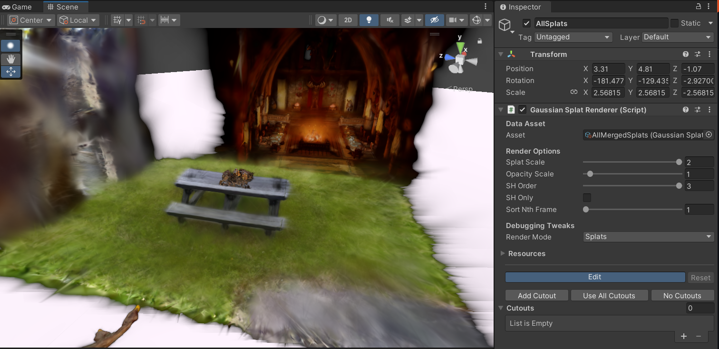

Figure 24: Unity Double Global Splat Scale

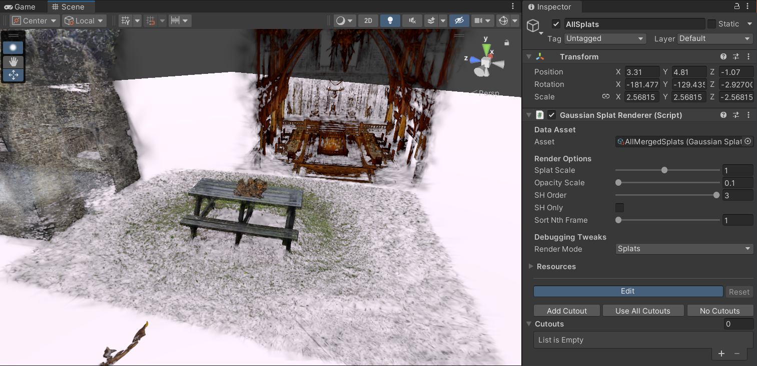

Figure 25: Unity 0.1 Splat Opacity

Multiple Splats can also be merged and exported as one Gaussian Splat, which is very useful for ensuring correct occlusion and creating novel scenes as demonstrated in the prototype (Figure 18).

#### Editing the Project Code

#### Assessing the code:

The Unity project heavily relies on complex C# script interactions and HLSL .shader language scripts to provide the rendering and editing of Gaussian Splats within Unity. To extend the functionality of the project a fundamental understanding of shader languages and Unity’s various scripting systems will be required. Vertex and Fragment Shader information can be found in the [Unity Shader Docs](https://docs.unity3d.com/6000.0/Documentation/Manual/writing-shader-programs-introduction.html) (Unity.com, 2025b). The Unity Editor API information can be referenced at [Unity Editor Docs](https://docs.unity3d.com/6000.0/Documentation/ScriptReference/Editor.html) (Unity.com, 2025c), with a tutorial at [Unity Editor Tutorial](https://learn.unity.com/tutorial/editor-scripting) (Unity.com, 2025a).

Editing the code:

Upon trying to open the project using Visual Studio the following error occurred:

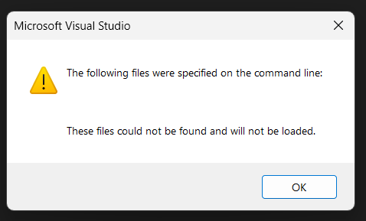

*Figure 26: Unity Project Visual Studio Error*

The error displayed in (Figure 26) was recreated across various hardware, two laptops and two desktop PCs running Windows 11 on both Nvidia and AMD hardware. A legacy 2017 version of Visual Studio was also tested with the same error occurring.

As such Visual Studio is unsuitable for editing the scripts and [JetBrains Rider](https://www.jetbrains.com/rider/) (JetBrains.com, 2025) was used instead.

After investigating the shader script with the project supervisor, it was noted that the shader openly affects the rendered Splats. For instance, in the RenderGaussianSplats.shader (Figure 27) script, the selection colour can be changed by altering the RGB value.

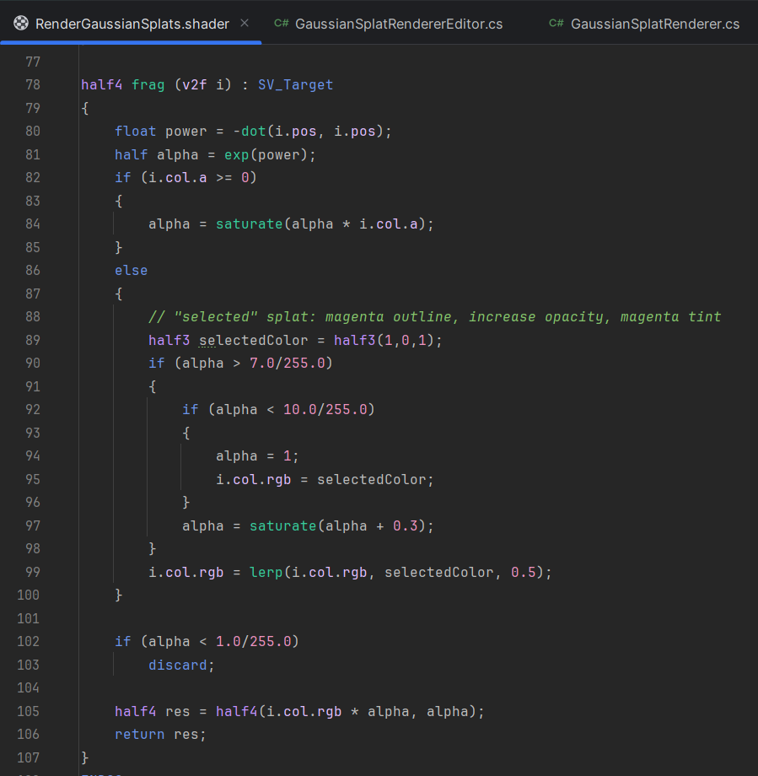

Figure 27: RenderGaussianSplats.shader Script Segment

Altering the selectedColor variable:





Figure 28: selectedColor Variable Code Alteration

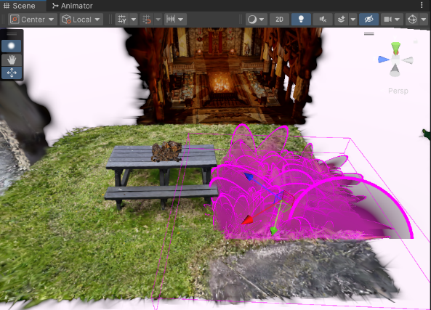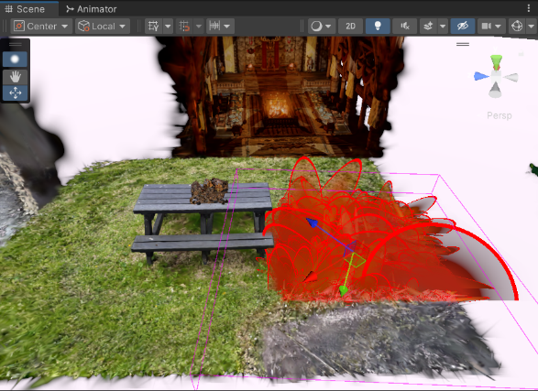

Figure 29: selectedColor Variable Code Alteration Result

Similarly, editing the RGBA values in the RenderGaussianSplats.shader script allows the alteration of the Splats globally:

For instance, multiplying the ‘r’ (red) part of the colour profile (Figure 30) has the expected result of increasing the red tint of the scene (Figure 31).  
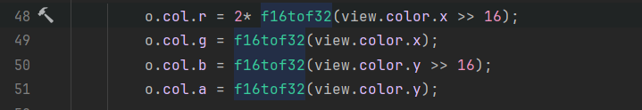

Figure 30: Altering Splat Colour Variables

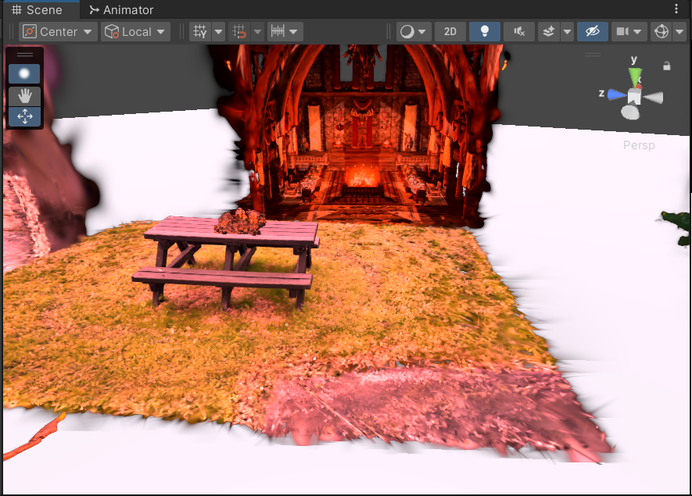

Figure 31: Altered Colour Profile

These initial alterations to the shader script showed the possibility of extending the functionality of the Unity project to allow individual and global colour alterations as desired. The main roadblocks at this time were adding this functionality into the existing Unity inspector UI and saving the changes permanently. An investigation into the code behind the current inspector UI (Figure 32) and expanding it was the next step.

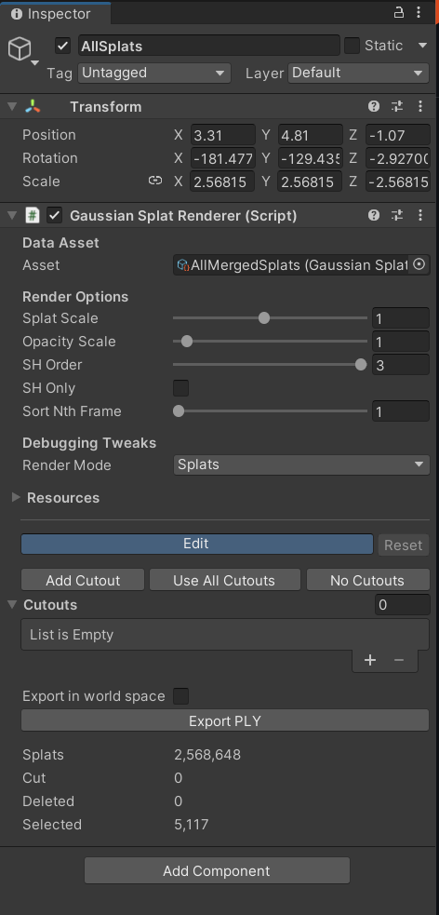

Figure 32: Original Unity Splat Inspector UI

The Inspector UI is dictated by the GaussianSplatRendererEditor.cs Script (Figure 33). Each serializedObject corresponds to a field in the Inspector.

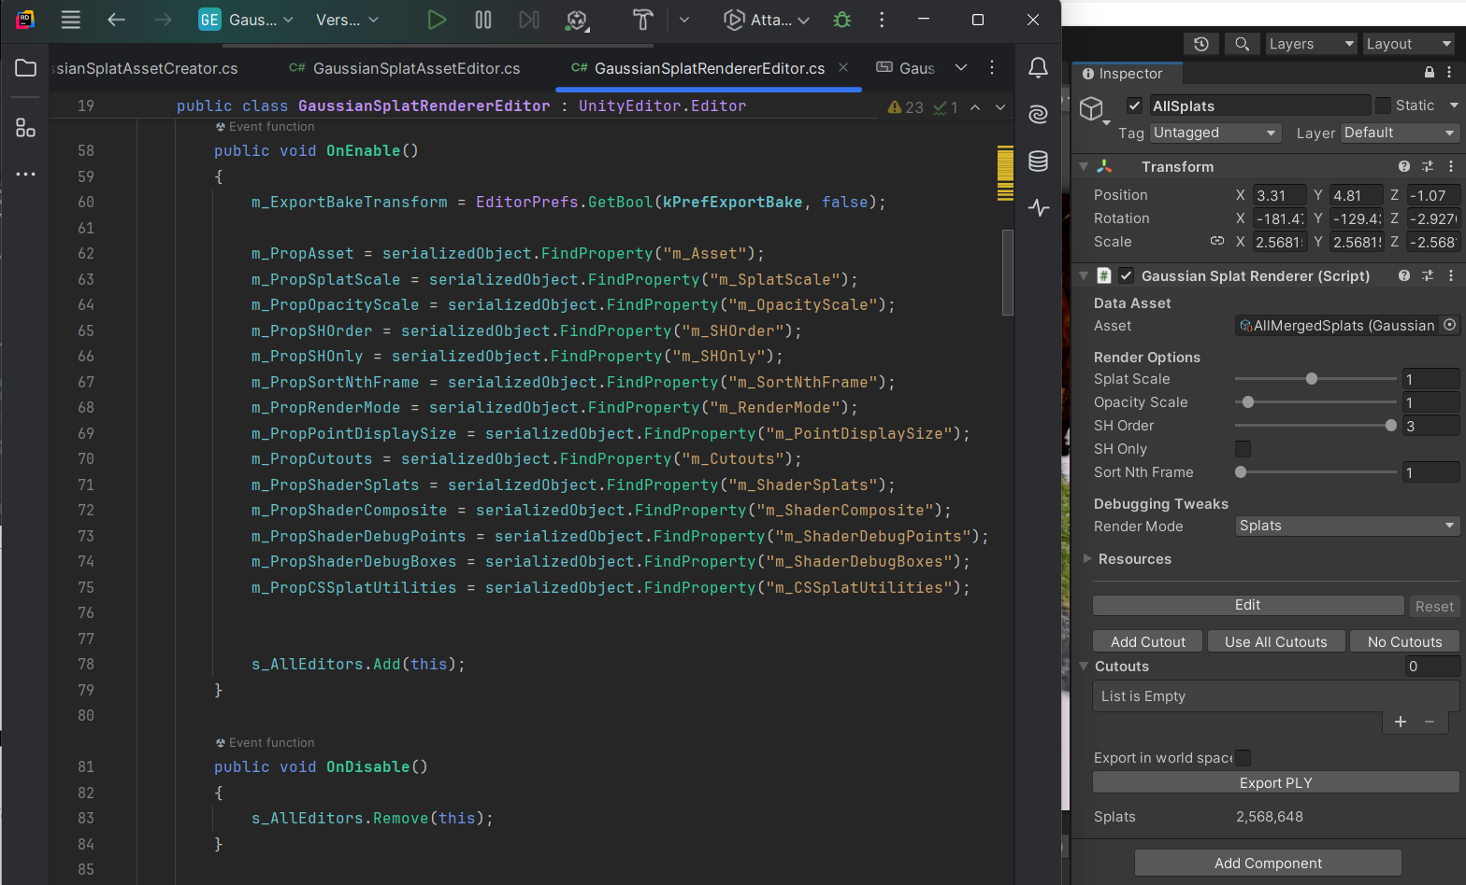

Figure 33: Unity Splat Editor Script Variables

This script logic can be edited and added to expand the Inspector UI, the additions in the GaussianSplatRendererEditor.cs script must be followed into the GaussianSplatRenderer Script as the editor script has references to the underlying renderer script. Once these changes are made correctly the updated fields are present in the inspector as seen in (Figure 34).

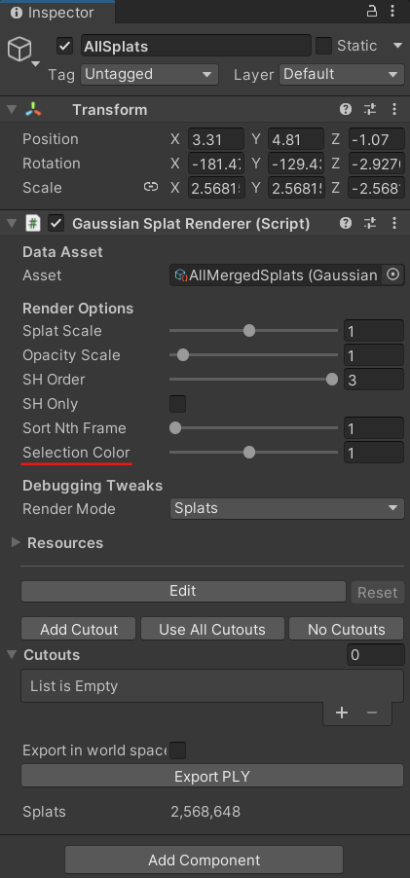

Figure 34: Unity Inspector Selection Colour Addition

The Selection Colour is currently set to alter the Splat Opacity as can be seen in the code snippet (Figure 35) affecting the Splats when altered in the inspector (Figure 36).

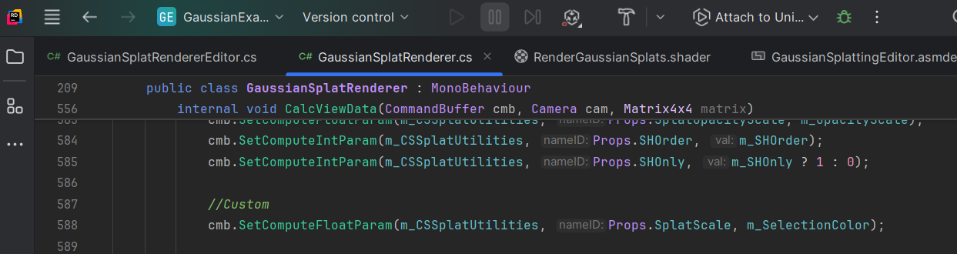

Figure 35: SelectionColor Variable

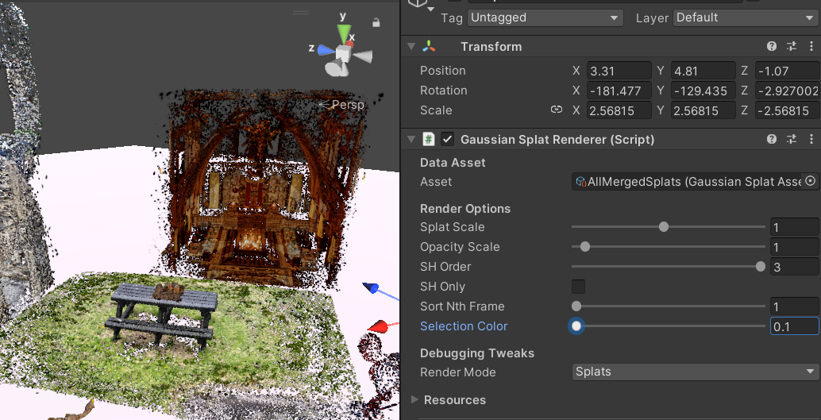

Figure 36: Selection Color Inspector

#### Sprint Retrospective

With the addition of the Unity inspector UI, the sprint came to an end. Understanding the current functionality of this Unity project took longer than anticipated, as such not much progress was made in adding more functionality to the project. The additions made in this sprint were a good foundation for expanding the tools available. For the next Sprint, the goal was to add functionality to these new tools.

### Sprint 3: Unity Editing Tools Continued

## Unreal Engine Project Development

### Sprint 3: Capturing footage for Splats: 11th February – 24th February

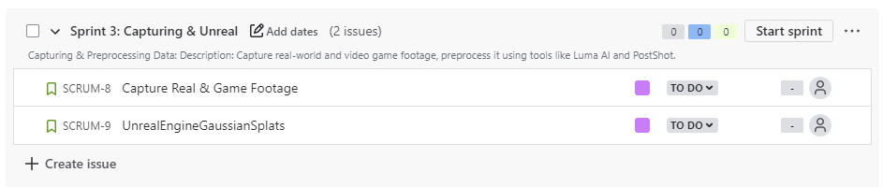

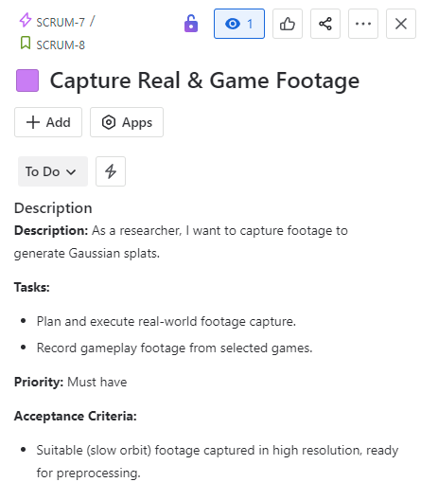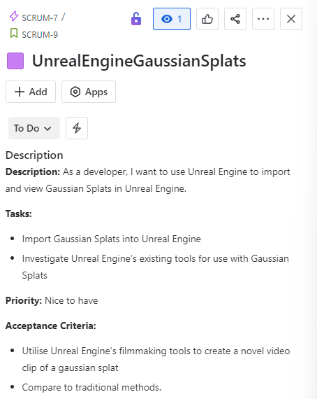

Goals: For this sprint, the goal was to capture and compare Gaussian Splats created from video footage from real-world footage and footage from screen recordings in games. Additionally, the Gaussian Splats were imported into Unreal Engine for display.

### Capturing Real World Footage

A DJI Osmo Pocket 3 was used to capture more footage to create Gaussian Splats. An example frame from a video captured (Figure 37) and its matching Gaussian Splat from LumaAI (Figure 38).

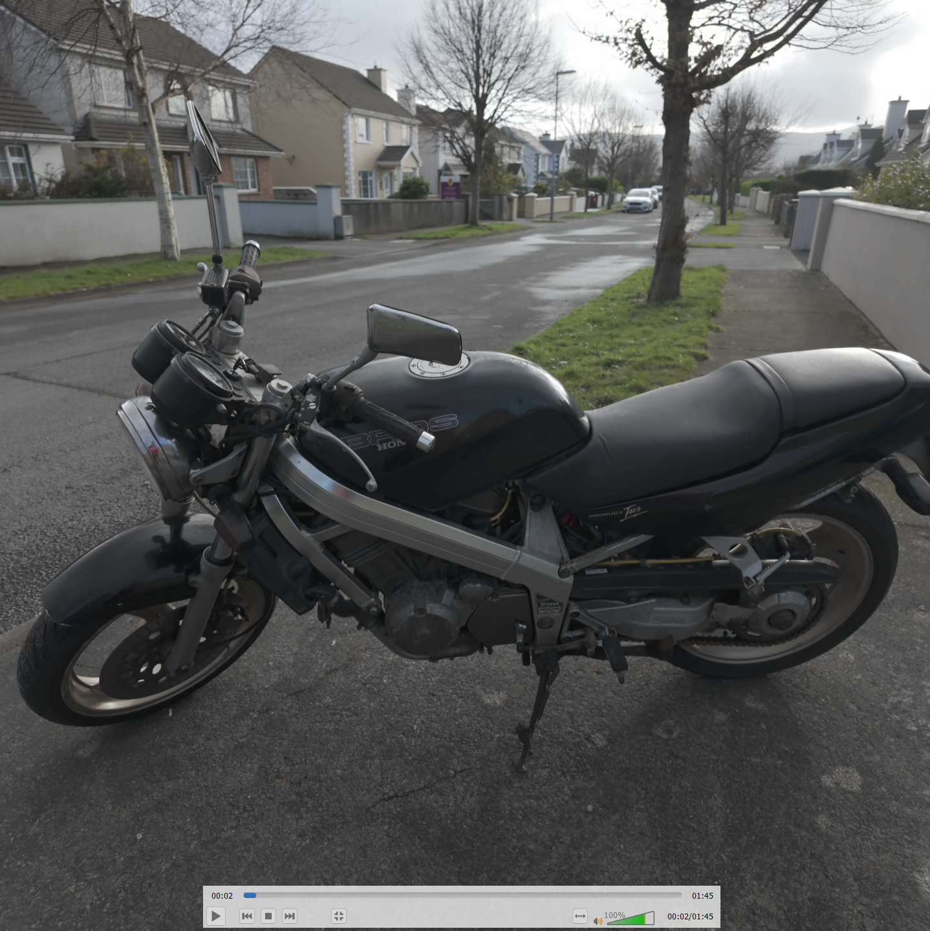

Figure 37: Motorbike Video Frame

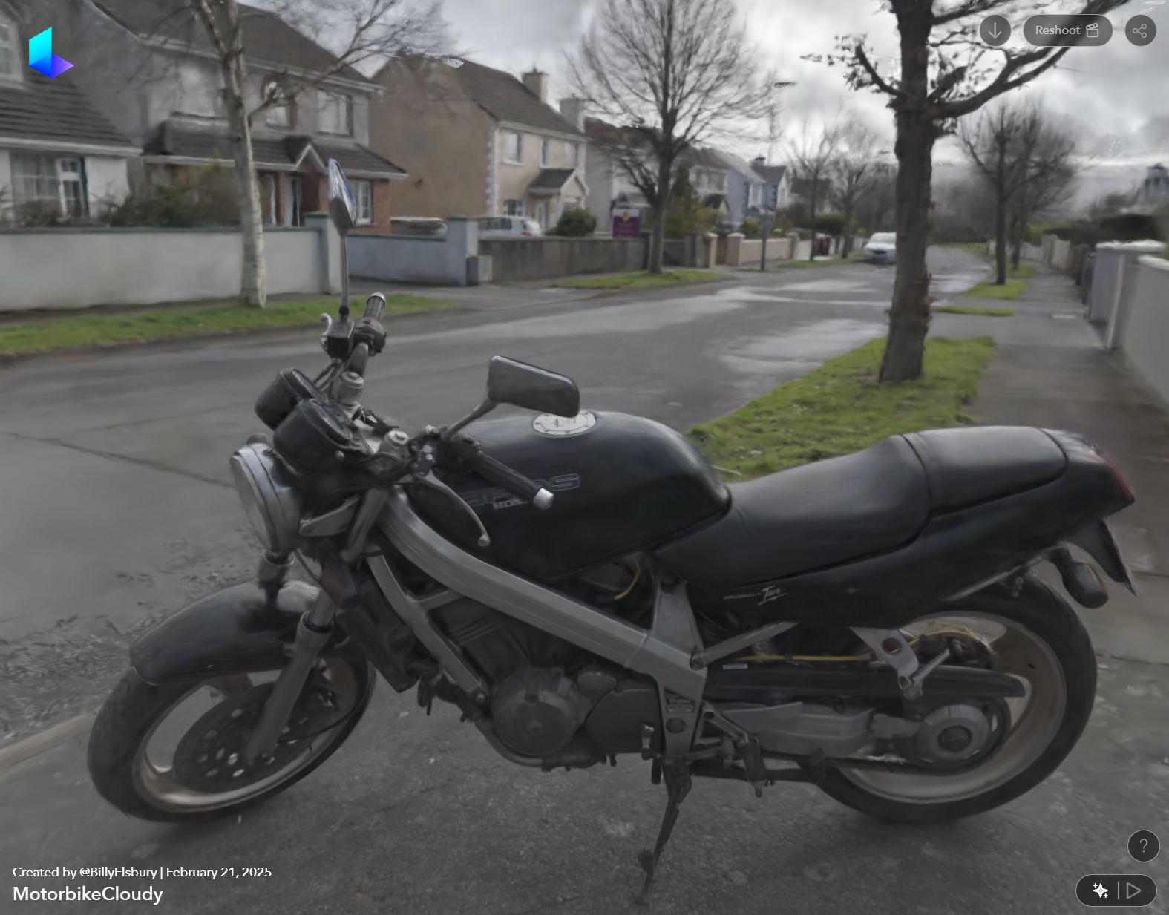

Figure 38: Motorbike Gaussian Splat

### Capturing Video Game Footage

Footage from several games using AMD’s screen recording (AMD.com, 2025)

A frame of the footage captured from the video game Horizon Forbidden West (Figure 39) and the Gaussian Splat (Figure 40) created from the video footage, shows the faithful recreation of a 3D scene that the Gaussian Splatting process provides.

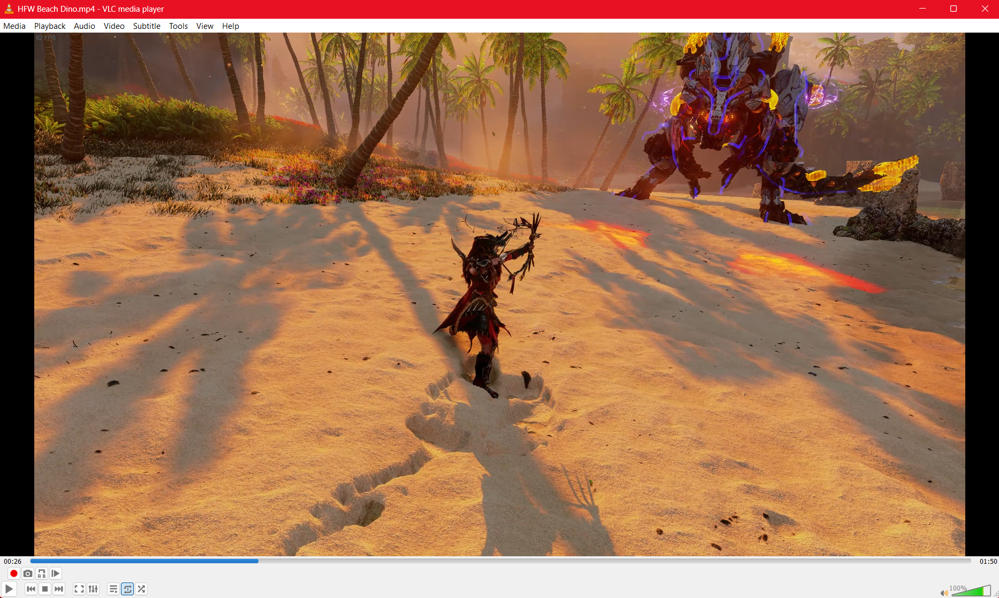

Figure 39: Horizon Forbidden West Video Frame

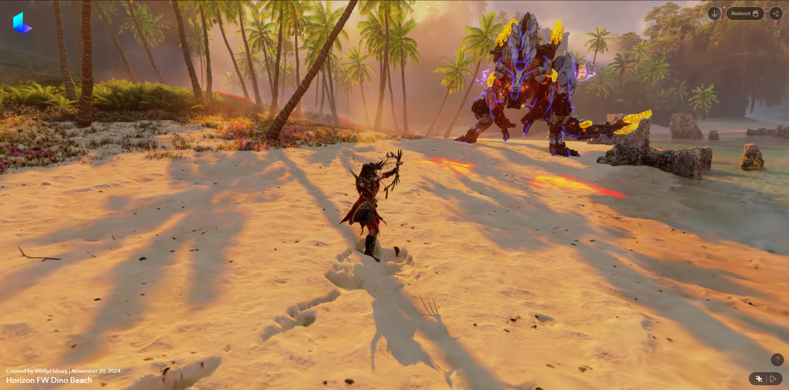

Figure 40: Horizon Forbidden West Gaussian Splat Frame

### Importing Gaussian Splats into Unreal Engine

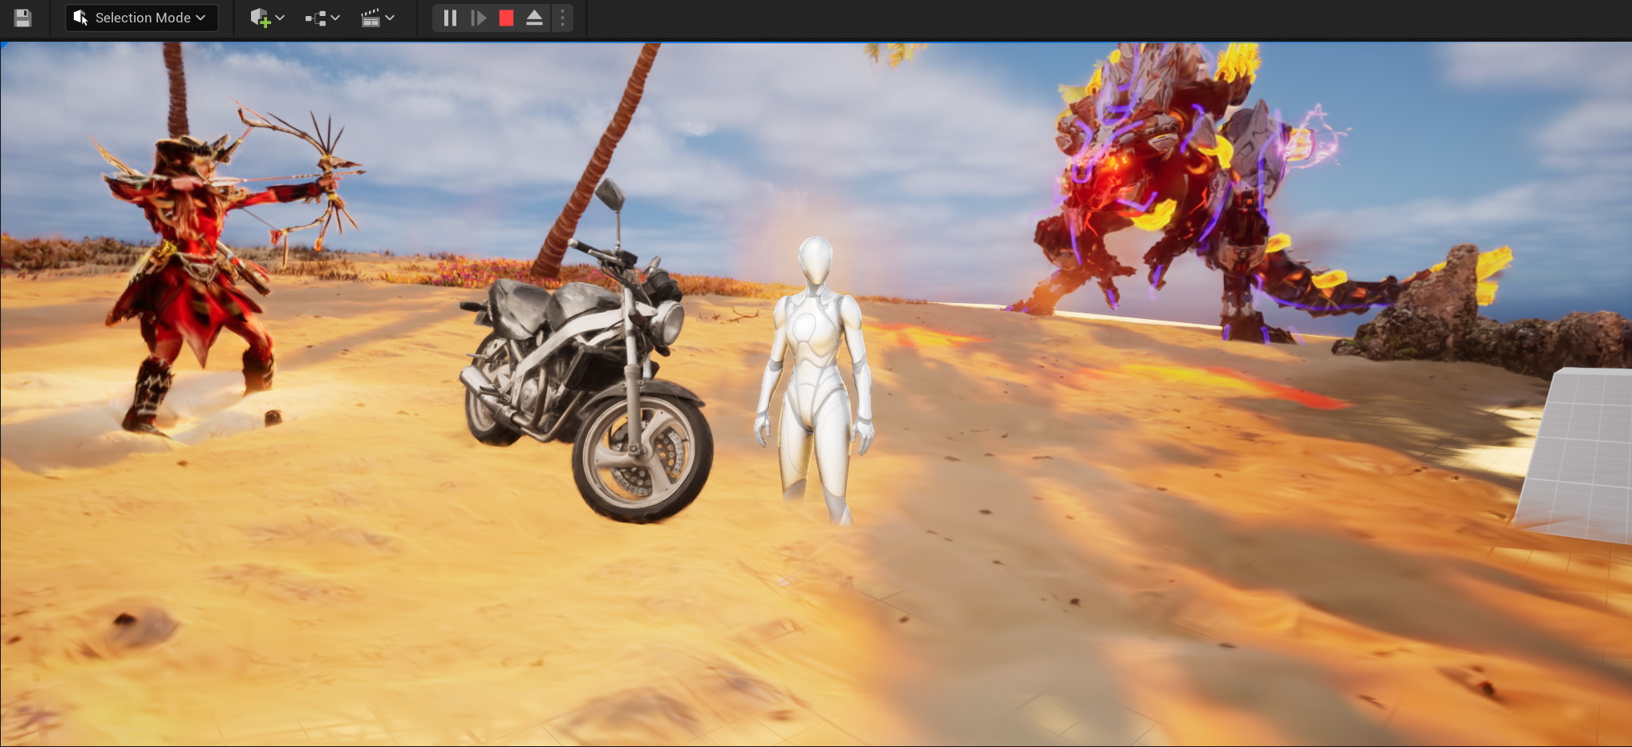

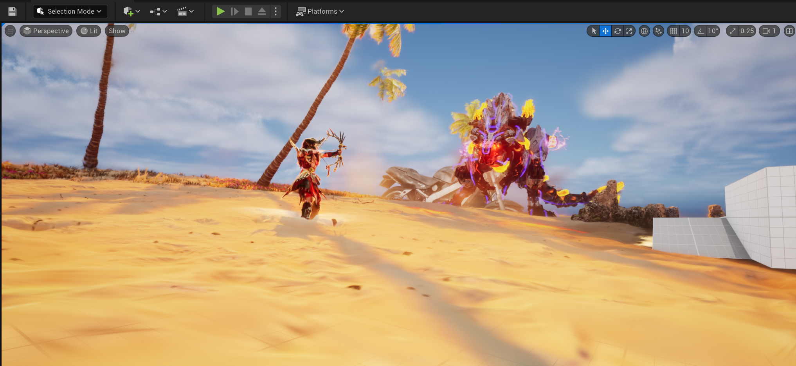

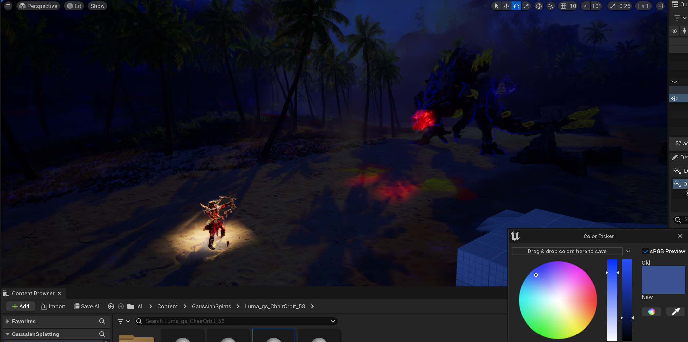

### Sprint 4: Importing Splats into Unreal: 25th February – 24th February

# Conclusion

# Figures

Figure 1 Rasterised Triangle & Gaussian representation (Ebert, 2023) 4

Figure 2 Gaussian Function (Weisstein, 2024) 5

Figure 3: SuperSplat Original Colour 8

Figure 4: SuperSplat Edited Colour 8

Figure 5: The Vanishing of Ethan Carter Photoscanned building (Poznanski, 2014) 9

Figure 6: LumaAI Lara Croft Face Gaussian Splat 14

Figure 7: LumaAI Lara Croft NeRF 14

Figure 8: Post Shot Gaussian Splat Parameters 15

Figure 9: Python Script Auto Camera Demonstration 19

Figure 10: LumaAI Upload Example 20

Figure 11: Jawset Postshot Training Example 20

Figure 12: Very High Import Setting 21

Figure 13: Very Low Import Setting 22

Figure 14: Gaussian Splat Comparison 22

Figure 15: High-Quality Import Performance Metrics 23

Figure 16: Low-Quality Import Performance Metrics 24

Figure 17: Incorrect Splat Occlusion Example 26

Figure 18: Final Merged Prototype Scene 26

Figure 19: Final Prototype Stats 27

Figure 20: Unity Project Imported Gaussian Splat 29

Figure 21: Unity Splat Selection 29

Figure 22: Unity Splat Movement 30

Figure 23: Unity Splat Deletion 30

Figure 24: Unity Double Global Splat Scale 31

Figure 25: Unity 0.1 Splat Opacity 31

*Figure 26: Unity Project Visual Studio Error* 32

Figure 27: RenderGaussianSplats.shader Script Segment 32

Figure 28: selectedColor Variable Code Alteration 33

Figure 29: selectedColor Variable Code Alteration Result 33

Figure 30: Altering Splat Colour Variables 33

Figure 31: Altered Colour Profile 34

Figure 32: Original Unity Splat Inspector UI 34

Figure 33: Unity Splat Editor Script Variables 35

Figure 34: Unity Inspector Selection Colour Addition 35

Figure 35: SelectionColor Variable 36

Figure 36: Selection Color Inspector 36

Figure 37: Motorbike Video Frame 39

Figure 38: Motorbike Gaussian Splat 39

Figure 39: Horizon Forbidden West Video Frame 40

Figure 40: Horizon Forbidden West Gaussian Splat Frame 40

# References

ACE, 2024. *ACE AgriTech Centre of Excellence*. [online] ACE AgriTech Centre of Excellence. Available at: <https://agritechexcellence.com/> [Accessed 9 December 2024].

Albertz, J., 2007. A Look Back; 140 Years of Photogrammetry. *PHOTOGRAMMETRIC ENGINEERING*.

AMD.com, 2025. *AMD Video and Streaming*. [online] AMD. Available at: <https://www.amd.com/en/products/software/adrenalin/video-streaming.html> [Accessed 6 April 2025].

Atreya, S., 2022. *THE EVOLUTION OF VIDEO GAME GRAPHICS AND THEIR IMPACT ON THE INDUSTRY - ProQuest*. [online] Available at: <https://www.proquest.com/openview/ec5dd0d458105086072444bd3ba74239/1?pq-origsite=gscholar&cbl=2035897> [Accessed 2 December 2024].

Beelitz, C., 1867. Die Photogrammetrie. *Wochenblatt des Architektenvereins zu Berlin*, No. 49, p.1.

Borycki, P., Smolak, W., Waczyńska, J., Mazur, M., Tadeja, S. and Spurek, P., 2024. *GASP: Gaussian Splatting for Physic-Based Simulations*. https://doi.org/10.48550/arXiv.2409.05819.

Clark, J.H., 1976. Hierarchical Geometric Models for Visible Surface Algorithms. *University of California at Santa Cruz*. [online] Available at: <https://web.archive.org/web/20060910212907/http://accad.osu.edu/%7Ewaynec/history/PDFs/clark-vis-surface.pdf> [Accessed 8 December 2024].

Dihlmann, J.-N., Majumdar, A., Engelhardt, A., Braun, R. and Lensch, H.P.A., 2024. *Subsurface Scattering for 3D Gaussian Splatting*. https://doi.org/10.48550/arXiv.2408.12282.

Ebert, D., 2023. *Introduction to 3D Gaussian Splatting*. [online] Available at: <https://huggingface.co/blog/gaussian-splatting> [Accessed 27 October 2024].

Fei, B., Xu, J., Zhang, R., Zhou, Q., Yang, W. and He, Y., 2024. 3D Gaussian Splatting as New Era: A Survey. *IEEE Transactions on Visualization and Computer Graphics*, pp.1–20. https://doi.org/10.1109/TVCG.2024.3397828.

Hanke, K. and Grussenmeyer, P., 2002. ARCHITECTURAL PHOTOGRAMMETRY: Basic theory, Procedures, Tools. *K .*

Ionos.com, 2023. *Frames per second (FPS) in TV, cinema, and gaming*. [online] IONOS Digital Guide. Available at: <https://www.ionos.com/digitalguide/server/know-how/fps/> [Accessed 8 December 2024].

Jawset.com, 2024. *Jawset Postshot*. [online] Available at: <https://www.jawset.com/> [Accessed 2 December 2024].

JetBrains.com, 2025. *Rider: The Cross-Platform .NET IDE from JetBrains*. [online] JetBrains. Available at: <https://www.jetbrains.com/rider/> [Accessed 9 February 2025].

Kerbl, B., Kopanas, G., Leimkühler, T. and Drettakis, G., 2023. *3D Gaussian Splatting for Real-Time Radiance Field Rendering*. https://doi.org/10.48550/arXiv.2308.04079.

Luebke, D., Reddy, M., Cohen, J.D., Varshney, A., Watson, B. and Huebner, R., 2002. *Level of Detail for 3D Graphics*. Elsevier.

Lumalabs.ai, 2024. *Luma AI - Interactive Scenes*. [online] Luma AI - Interactive Scenes. Available at: <https://lumalabs.ai/interactive-scenes> [Accessed 2 December 2024].

Mildenhall, B., Srinivasan, P.P., Tancik, M., Barron, J.T., Ramamoorthi, R. and Ng, R., 2020. *NeRF: Representing Scenes as Neural Radiance Fields for View Synthesis*. Available at: <http://arxiv.org/abs/2003.08934> [Accessed 27 October 2024].

Park, J.-H., Shin, Y.-D., Bae, J.-H. and Baeg, M.-H., 2012. Spatial Uncertainty Model for Visual Features Using a Kinect (TM) Sensor. *Sensors (Basel, Switzerland)*, 12, pp.8640–62. https://doi.org/10.3390/s120708640.

playcanvas.com, 2024. *SuperSplat*. [online] Available at: <https://playcanvas.com/supersplat/editor> [Accessed 8 December 2024].

Polidori, L., 2020. ON LAUSSEDAT’S CONTRIBUTION TO THE EMERGENCE OF PHOTOGRAMMETRY. *The International Archives of the Photogrammetry, Remote Sensing and Spatial Information Sciences*, XLIII-B2-2020, pp.893–899. https://doi.org/10.5194/isprs-archives-XLIII-B2-2020-893-2020.

Poly.cam, 2024. *Polycam - LiDAR & 3D Scanner for iPhone & Android*. [online] Available at: <https://poly.cam/> [Accessed 2 December 2024].

Poznanski, A., 2014. Visual Revolution of The Vanishing of Ethan Carter. *The Astronauts*. Available at: <https://www.theastronauts.com/2014/03/visual-revolution-vanishing-ethan-carter/> [Accessed 9 December 2024].

Pranckevičius, A., 2024. *Toy Gaussian Splatting visualization in Unity*. Available at: <https://github.com/aras-p/UnityGaussianSplatting> [Accessed 2 December 2024].

Radl, L., Steiner, M., Parger, M., Weinrauch, A., Kerbl, B. and Steinberger, M., 2024. StopThePop: Sorted Gaussian Splatting for View-Consistent Real-time Rendering. *ACM Trans. Graph.*, 43(4), p.64:1-64:17. https://doi.org/10.1145/3658187.

Seo, Y., Choi, Y.S., Son, H.S. and Uh, Y., 2024. *FLoD: Integrating Flexible Level of Detail into 3D Gaussian Splatting for Customizable Rendering*. https://doi.org/10.48550/arXiv.2408.12894.

Snavely, N., Seitz, S.M. and Szeliski, R., 2006. Photo tourism: exploring photo collections in 3D. In: *ACM SIGGRAPH 2006 Papers*, SIGGRAPH ’06. [online] New York, NY, USA: Association for Computing Machinery. pp.835–846. https://doi.org/10.1145/1179352.1141964.

Statham, N., Jacob, J. and Fridenfalk, M., 2020. Photogrammetry for Game Environments 2014-2019: What Happened Since The Vanishing of Ethan Carter. In: *Proceedings of DiGRA 2020 Conference: Play Everywhere*. [online] Proceedings of DiGRA 2020 Conference: Play Everywhere. . Available at: <https://dl.digra.org/index.php/dl/article/view/1225> [Accessed 27 October 2024].

Statham, W., 2020. Use of Photogrammetry in Video Games: A Historical Overview. *Games and Culture*, 15(3), pp.289–307. https://doi.org/10.1177/1555412018786415.

Unity.com, 2025a. *Editor Scripting Tutorial*. [online] Unity Learn. Available at: <https://learn.unity.com/tutorial/https:/learn.unity.com/tutorial/editor-scripting> [Accessed 9 February 2025].

Unity.com, 2025b. *Unity - Manual: Shader program fundamentals*. [online] Available at: <https://docs.unity3d.com/6000.0/Documentation/Manual/writing-shader-programs-introduction.html> [Accessed 9 February 2025].

Unity.com, 2025c. *Unity - Scripting API: Editor*. [online] Available at: <https://docs.unity3d.com/6000.0/Documentation/ScriptReference/Editor.html> [Accessed 9 February 2025].

Wang, J., Zhang, Q., Sun, J., Cao, J., Han, G., Zhao, W., Zhang, W., Shao, Y., Guo, Y. and Xu, R., 2024. *Reinforcement Learning with Generalizable Gaussian Splatting*. https://doi.org/10.48550/arXiv.2404.07950.

Weisstein, E.W., 2024. *Gaussian Function*. [Text] Available at: <https://mathworld.wolfram.com/GaussianFunction.html> [Accessed 2 October 2024].

Westover, L.A., 1991. SPLATTING: A Parallel, Feed-Forward Volume Rendering Algorithm.

Wu, T., Yuan, Y.-J., Zhang, L.-X., Yang, J., Cao, Y.-P., Yan, L.-Q. and Gao, L., 2024. Recent advances in 3D Gaussian splatting. *Computational Visual Media*, 10(4), pp.613–642. https://doi.org/10.1007/s41095-024-0436-y.